DESIGN AND DEVELOPMENT OF COMMUNITY INCIDENT REPORTING

CHAPTER ONE

INTRODUCTION

1.0 Overview
Rapid urban growth increases the need for effective systems through which residents can report hazards and receive timely information about response actions. In the Accra Metropolitan Area, flooding, crime, fire outbreaks, medical emergencies, and infrastructure faults can disrupt daily life, damage property, threaten lives, and place pressure on public-safety and emergency-response institutions. Greater Accra is Ghana’s most populous region, and Ghana’s 2021 census recorded a continuing concentration of population in urban areas, creating a strong basis for locally responsive digital public-service systems (Ghana Statistical Service, 2021).
This study concerns the design and development of a Geospatial Community Incident Reporting and Response System (CIRS) for the Accra Metropolitan Area. The system enables citizens to submit incident reports through web and mobile interfaces, while administrators and response teams can verify reports, assign responsibilities, update incident progress, and close completed cases. It integrates location capture, map visualisation, media attachments, status tracking, role-based access control, analytics, announcements, feedback, and audit logs.

1.1 Background of the Study
Community safety depends partly on how quickly residents can communicate hazards and how efficiently responsible institutions can assess, prioritise, and respond to them. In many communities, reports are made through telephone calls, personal visits, informal messages, or social-media posts. Although these channels can be useful, they are often unstructured and may omit essential information such as the precise location, severity, category, photographs, time of occurrence, and contact details of the reporter. Such gaps can make verification, prioritisation, dispatch, follow-up, and accountability difficult.
Flooding is an important concern in Accra because blocked drains, heavy rainfall, inadequate drainage capacity, unplanned development, and settlement in vulnerable areas can expose residents and infrastructure to flood-related risk. The Greater Accra Regional Coordinating Council’s development plan identifies flood mitigation, urban water management, drainage improvement, and flood-hotspot mapping as key priorities. This establishes a need for systems that enable residents to report flooded roads, blocked drains, overflowed waterways, damaged culverts, and other environmental hazards with accurate location data (Greater Accra Regional Coordinating Council, 2026).
Crime and safety-related incidents also require accessible reporting mechanisms. Residents may observe theft, suspicious activity, vandalism, assault, street-light failure, or other safety threats. However, people may be unwilling or unable to make a formal report immediately, particularly when they are concerned about personal identification or safety. A platform that permits anonymous reporting while providing administrators with tools to verify, reject, classify, or flag duplicate reports can widen access while maintaining workflow controls.
Fire incidents require speed, location accuracy, and appropriate dispatch coordination. A delay in communicating the location, type, severity, or available visual evidence of a fire can increase risks to people, buildings, businesses, and surrounding communities. Likewise, medical emergencies may require a rapid record of the event location and situation so that an appropriate response team can assess and manage the report. The CIRS therefore supports structured incident categories, severity levels, geotagging, address information, images or videos, and assignment of specialised response teams, including Fire, Police, Medical, Flood/Disaster, and General teams.
Infrastructure faults also affect quality of life and public safety. Examples include damaged roads, fallen trees, broken traffic signals, open drains, failed streetlights, burst pipes, and unsafe public structures. When these faults are reported through fragmented channels, authorities may lack a central record for identifying recurring issues, monitoring response status, or detecting geographical clusters. Geographic Information System (GIS) functions can improve this situation by presenting incident locations visually and allowing incident records to be filtered by category, severity, status, and date.
The National Disaster Management Organisation identifies emergency preparedness, response coordination, reporting hazards, and tracking relief or response as important components of disaster management in Ghana. The proposed system does not replace official emergency hotlines or legally mandated emergency-management structures. Rather, it demonstrates a community-oriented digital platform that can improve the information flow from citizens to responsible administrators and response teams (National Disaster Management Organisation, 2023).

1.2 Problem Statement
Residents in the Accra Metropolitan Area may encounter flooding, crime, fire, medical emergencies, safety hazards, and infrastructure faults that require prompt attention. However, conventional reporting methods can be fragmented, delayed, unstandardised, and difficult to track. A telephone call, verbal complaint, walk-in report, or social-media post may not provide precise coordinates, category, severity, visual evidence, or a traceable response history.
Furthermore, where reports are recorded separately by different individuals or offices, decision makers may lack a central platform for verifying reports, identifying duplicate submissions, assigning response teams, monitoring field action, communicating updates, and analysing incident patterns. This weakens situational awareness and makes it more difficult to establish whether an incident has been addressed satisfactorily.
The problem addressed by this study is therefore the absence of an integrated, multi-platform, geospatial incident reporting and response system for the Accra Metropolitan Area that enables citizens to submit structured incident reports and enables authorised personnel to verify, dispatch, monitor, resolve, and analyse those reports through controlled workflows.

1.3 Aim and Objectives

1.3.1 Aim
The aim of this study is to design and develop a geospatial community incident reporting and response system for the Accra Metropolitan Area.

1.3.2 Objectives
The objectives of the study are to:
- Examine challenges associated with fragmented community incident reporting for flooding, crime, infrastructure faults, fire, medical emergencies, and related public-safety events.
- Design a role-based system architecture that supports Citizen Reporters, Response Teams, Administrators, and Super Administrators.
- Develop web and mobile interfaces that allow anonymous and authenticated users to submit geotagged incident reports with category, severity, description, address, and media evidence.
- Implement administrative functions for report verification, rejection, duplicate handling, team assignment, status updates, public updates, and incident closure.
- Implement response-team functions for acknowledgement, field progress updates, evidence upload, and incident resolution.
- Provide interactive mapping, filtering, incident monitoring, and analytics to support situational awareness and informed decision-making.
- Incorporate security controls including token-based authentication, role-based access control, validation, rate limiting, and audit logging.
- Evaluate the system’s functionality, usability, reliability, and suitability as an academic prototype for community incident reporting and response.

1.4 Significance of the Study
The study is significant to community members because it provides a structured digital channel for reporting incidents. Residents can provide richer information than is normally possible through a brief verbal complaint, including location coordinates, an address, incident category, severity, narrative description, and media evidence. They can also monitor the status of authenticated reports and provide feedback after a response.
The study is significant to administrators because it centralises incident management activities. Administrators can review pending reports, verify or reject reports, identify duplicates, assign specialised teams, add notes, update incident status, generate public updates, and export selected records. These functions can improve visibility over the operational workflow and provide clearer accountability for each report.
The study is significant to response teams because it provides an assigned-incident queue and a structured process for acknowledging dispatches, posting field updates, adding proof of action, and recording resolution. This can support coordination among teams responsible for fire, police, medical, flood/disaster, and general incidents.
The study is also significant to planners and researchers because location-tagged incident records can be represented on maps and summarised in dashboards. Category distributions, status breakdowns, response performance, and emerging spatial patterns can contribute to evidence-informed planning, subject to the quality and completeness of voluntary reports.

1.5 Scope of the Study
The study covers the analysis, design, and development of a prototype Geospatial Community Incident Reporting and Response System for the Accra Metropolitan Area. The platform consists of a web application, mobile application, RESTful backend API, database, media-storage component, mapping capability, notification features, and analytical dashboards.
- Anonymous and authenticated incident reporting.
- User registration, login, profile management, and token-based authentication.
- Incident category selection, severity classification, descriptions, date and time records, GPS coordinates, address information, and media attachments.
- Incident status management, including pending, under review, assigned, in progress, resolved, closed, rejected, and duplicate-report handling.
- Administrative verification, response-team dispatch, reassignment, report filtering, user and team management, announcements, analytics, and audit-log review.
- Response-team acknowledgement, operational updates, media proof, and resolution confirmation.
- Map-based display and filtering of appropriate public incident records.
- Citizen feedback through ratings and comments after incident handling.

1.6 Limitations of the Study
The developed system is an academic prototype and is not a replacement for Ghana’s official emergency services, public emergency hotlines, NADMO operations, police services, fire services, ambulance services, or formal government incident-command systems. It does not claim formal integration with those institutions.
The completeness and reliability of incident data depend partly on user participation and the accuracy of submitted information. Reports may be incomplete, duplicated, malicious, inaccurate, or affected by GPS limitations. The system mitigates some of these risks through validation, administrative verification, duplicate marking, access controls, and audit logs; however, these controls cannot guarantee the truthfulness of every report.
System performance may depend on availability of internet connectivity, device performance, location permissions, external map services, and hosting resources. Further work would be required before production deployment to conduct extensive penetration testing, accessibility testing, load testing, data-protection assessment, multilingual design, disaster-recovery planning, and institutional integration.

1.7 Organisation of the Study
Chapter One: Introduction
This chapter introduces the study by presenting its background, problem statement, aim, objectives, significance, scope, and limitations.
Chapter Two: Literature Review
Present a review of relevant literature, existing systems, GIS-enabled reporting, mobile and web platforms, usability, security, and the justification for the proposed system.
Chapter Three: System Specification and Design
presents the system analysis, design, methodology, requirements, diagrams, workflow, and architecture.
Chapter Four: System Implementation
Details the system design and implementation, covering the architecture, database schema, user interfaces, and geospatial components. It also presents the results of system testing and user evaluation, analyzing usability, performance, and perceived usefulness.
Chapter Five: Conclusion and Recommendation
Provides the summary of the key findings and achievements of the study, discusses challenges encountered, and suggests possible future improvements to enhance the system.

CHAPTER TWO

LITERATURE REVIEW

2.0 Overview
This chapter reviews concepts and systems relevant to community incident reporting and response. It considers citizen participation, geospatial reporting, web and mobile technologies, report verification, role-based workflows, operational accountability, usability, and security. It also reviews the systems presented in the original report and relates their strengths and limitations to the CIRS.

2.1 Community Incident Reporting Systems
A community incident reporting system is a digital platform that enables residents or authorised personnel to report an event, hazard, fault, emergency, or safety concern to a responsible organisation. The report usually includes structured information such as the incident category, description, time, location, severity, and supporting evidence. The responsible organisation can then use this information to assess the report, allocate resources, communicate updates, and maintain a record of actions taken.
Such systems are valuable because they convert dispersed observations from community members into structured operational information. Instead of relying only on informal social-media posts, unrecorded telephone calls, or verbal complaints, an incident reporting system creates a traceable incident record. When geospatial information is included, decision makers can locate reports on a map, identify concentrations of similar incidents, and consider whether resources should be deployed differently.
For the CIRS, a report is not treated as complete merely because it has been submitted. It passes through a managed lifecycle: report submission, verification or rejection, assignment to an appropriate response team, acknowledgement, progress updates, resolution, administrative closure, and optional citizen feedback. This workflow responds to a key limitation of systems that collect reports but provide little visibility of the action taken afterwards.

2.1.1 Citizen Participation and Crowdsourced Reporting
Citizen reporting is a form of participatory information collection. Community members are often physically close to an incident and may notice problems before a formal response organisation is aware of them. Their reports can supplement official information sources, particularly for local hazards such as flooded streets, blocked drains, damaged roads, fallen trees, unsafe structures, streetlight failures, or small fires.
However, citizen-generated information has limitations. Users may submit reports with incorrect descriptions, inaccurate locations, missing evidence, duplicates, or misleading content. A useful platform should therefore balance accessibility with controls that support quality. The CIRS addresses this concern by allowing administrators to verify or reject submitted incidents, add administrative notes, mark reports as duplicates, apply status changes, and use audit logs to record material system actions.
Anonymous reporting is another important design consideration. It may encourage people to report sensitive events or public-safety concerns where they fear exposure. Yet anonymity can make validation more difficult. The system supports anonymous reporting while retaining administrative review and operational workflows. Authenticated users, in contrast, can access personal report histories, receive status updates, and submit feedback after closure.

2.1.2 Geospatial Technology and Incident Management
Geospatial technology supports the capture, storage, display, and analysis of information connected to a physical location. In incident management, latitude and longitude coordinates, street addresses, map markers, clustered points, and location filters help users understand where incidents occur.
The principal advantage of a geospatial approach is that location becomes an operational attribute rather than an optional narrative detail. A resident can use a device’s location capability to tag an incident, while a map interface can allow the user to adjust a location pin where necessary. Administrators can then view incidents by category, severity, date, or status, and response teams can use the coordinates and incident address when handling assignments.
Geospatial information is particularly relevant in Accra, where flooding, infrastructure faults, crime, fire, and medical incidents may occur across diverse neighbourhoods. Flood-risk mitigation and hotspot mapping are identified as development priorities within Greater Accra’s planning context. A map-enabled reporting system can contribute useful community-level information, though it cannot replace official hydrological models, emergency-command systems, or formal disaster assessments.

2.1.3 Web and Mobile Reporting Platforms
Web applications provide access through a desktop or mobile browser, making them appropriate for administrative dashboards, public maps, reports, and detailed data-management tasks. Mobile applications provide direct access to device capabilities, including GPS, cameras, local storage, and notifications. A multi-platform approach can therefore serve different user needs.
The CIRS includes a React-based web application and a React Native mobile application. The mobile application supports GPS-based location capture and device camera or gallery access for incident evidence. The web application provides public reporting, an interactive map, user dashboards, administrative management, response-team workflows, analytics, announcements, and audit-log access. Both clients communicate with the same backend REST API, which helps maintain a shared incident record and workflow across platforms.
An important limitation of web and mobile systems is reliance on connectivity, compatible devices, location permissions, and user digital literacy. For this reason, the proposed system should be treated as an additional communication tool rather than the only means of reporting emergencies.

2.1.4 Incident Verification and Dispatch Workflows
The usefulness of an incident platform depends not only on report collection but also on the workflow used to handle reports. Verification is necessary because administrators may need to assess the completeness, credibility, severity, duplication, and category of a report before dispatching limited response resources.
The CIRS includes a controlled workflow in which an incident begins in a pending state. An administrator can review it, place it under review, verify it, reject it with a reason, or mark it as a duplicate. Once verified, the incident may be assigned to a specialised response team. The assigned team can acknowledge the incident, provide operational updates, upload media evidence, and mark the incident as resolved. An administrator can subsequently close the incident, creating a clear record of responsibility and status progression.

2.1.5 Usability and Accessibility
Usability concerns whether intended users can achieve their goals effectively, efficiently, and satisfactorily in a specific context of use. ISO 9241-11 frames usability as an outcome that depends on users, tasks, equipment, and the environment in which a system is used (International Organization for Standardization [ISO], 2018).
For a community incident reporting system, usability requires clear labels, understandable categories, guided reporting forms, visible status indicators, meaningful error messages, responsive interfaces, and role-appropriate dashboards. A person reporting a fire, flood, medical emergency, or safety hazard should not have to navigate complex technical screens before submitting essential details.
The CIRS uses a multi-step incident form with category selection, severity selection, location capture, map pin placement, narrative description, and file attachment. It also separates the experience of Citizen Reporters, Response Teams, Administrators, and Super Administrators so that each role sees only relevant functions.

2.1.6 Security, Privacy, and Accountability
Incident reports may contain personal data, location coordinates, media evidence, sensitive descriptions, and operational notes. A secure platform therefore requires authentication, authorisation, validation, appropriate data handling, protection against brute-force access attempts, and activity traceability.
The CIRS uses token-based authentication for protected API access and role-based access control to restrict actions according to the user’s role. It also implements input validation, rate limiting for selected public authentication routes, media-type controls, and audit logging of system state changes. The audit log records the user, action, model type, time, IP address, user agent, and relevant before-and-after changes where applicable.
These features support accountability, but full production deployment would require additional controls, including privacy-impact assessment, secure hosting configuration, encryption in transit and at rest, backups, monitoring, incident-response procedures, and independent security testing.

2.2 Review of Existing Systems

2.2.1 Project SIGAW
The original report reviewed Project SIGAW as a community-based incident reporting and mapping system that uses Google Maps. Its main contribution is the integration of public reporting and location visualisation. The system demonstrates the value of allowing residents to report incidents and observe reports on an interactive map. The original report also identifies limitations relating to dependence on third-party mapping services, restricted geographic context, and insufficiently described security controls.
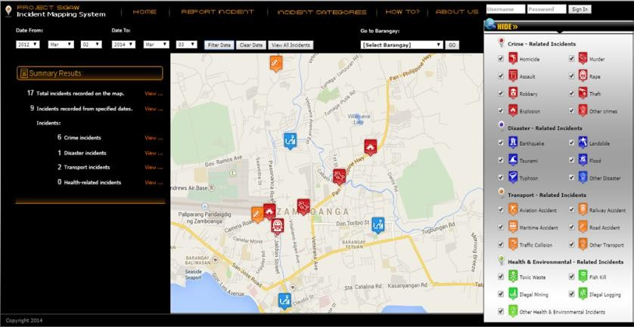Figure 2.1. Screenshot of Project SIGAW.

Advantages of Project SIGAW
- One of the greatest strengths of this study is that it addresses a real community problem: the lack of an efficient system for reporting and monitoring incidents. The researchers recognized that manual reporting methods and social media are inadequate for managing and verifying incident information, so they developed a centralized reporting platform.
- Unlike many incident management systems that only allow authorities to report incidents, Project SIGAW allows community members to Report incidents, Confirm reported incidents, and Give feedback on incidents.
- The integration of Google Maps is one of the strongest contributions of the research. Incident locations are displayed on an interactive map using color-coded markers and reverse geocoding, which converts GPS coordinates into readable street addresses.

Disadvantages of Project SIGAW
- The system relies heavily on Google Maps and Google APIs for mapping and geocoding. Changes in Google's pricing or API policies could affect the system. Internet connectivity is required for mapping features. Service interruptions from Google could impact functionality.
- The research focuses only on Zamboanga City. The findings may not apply to other cities with different infrastructure, population sizes, or reporting needs. Additional studies would be needed to confirm its effectiveness elsewhere.
- The paper focuses on system functionality but provides very little information about; data encryption, user authentication, privacy protection and cybersecurity. This is important because incident reports may contain sensitive personal or location data.

The CIRS builds on the strengths of this type of system by incorporating public map visualisation and community reporting. It extends the workflow through anonymous reporting, authenticated reporting, role-based dashboards, verification, duplicate handling, response-team assignment, response updates, resolution evidence, feedback, analytics, announcements, and audit trails.

2.2.2 Mobile Incident Reporting Application
The original report also reviewed a mobile incident reporting application that supports report submission, GPS-based location capture, photographs, and communication with responders. The key insight from this type of application is that mobile devices can enable residents to provide location-aware and evidence-supported reports at or near the scene of an incident.
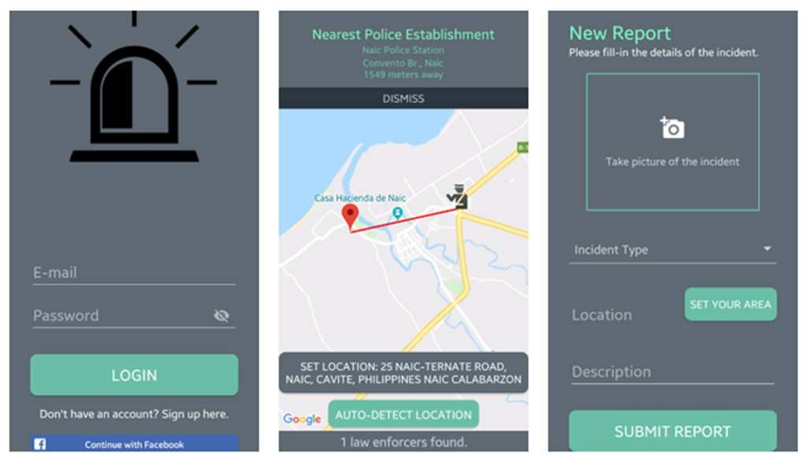Figure 2.2. Screenshot of the mobile incident reporting application.
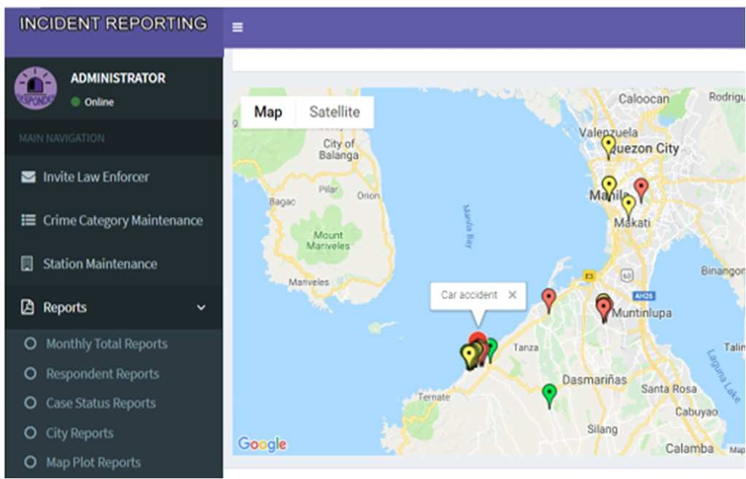Figure 2.3. Screenshot of the mobile application backend features.
The limitation of a mobile-only approach is that administrators often need larger-screen dashboards for filtering, review, analytics, team management, and auditing. The CIRS addresses this limitation through a shared web and mobile architecture. The mobile application supports field-oriented activities such as reporting, GPS capture, and response updates, while the web interface supports detailed management and analysis.

Advantages
- The system supports real-time incident reporting: The application allows citizens to submit reports immediately using their smartphones. Reports include Incident category, Description, Photographs, and GPS location. These reports are instantly sent to the nearest responder for action which enables faster communication between citizens and authorities. Reduces delays associated with manual reporting and improves emergency response coordination.
- The system uses GPS and Google Maps for accurate location tracking: The application automatically detects the user's latitude and longitude through GPS. If necessary, users can manually pin their location on Google Maps before submitting the report. This improves the accuracy of incident locations.
- The system allows users to include multimedia in their incident reporting as evidence: Users can attach photographs when submitting reports to provides visual evidence of incidents. Helps responders assess the seriousness of a situation before arriving and also improves the reliability of reported information.

Disadvantages
- The application relies heavily on Internet connectivity, GPS services, and Google Maps. Without these technologies, many of its features would not function effectively. Rural areas with poor network coverage may experience difficulties. GPS inaccuracies could affect response times. Internet outages could interrupt reporting.
- The system was developed using Android Studio, indicating that it targets Android devices. iPhone (iOS) users may not be able to use the application. This reduces accessibility for users on different mobile platforms.
The paper does not explain in detail how the system detects or prevents Fake reports, malicious users, duplicate submissions, and misuse of the reporting system. False reports could waste emergency resources and delay responses to genuine incidents.

2.2.3 Web-Based GIS Traffic Incident Management System
The third reviewed system is a web-based GIS platform focused on traffic incident management. Its major strength is the use of mapped incident data to improve visibility and support management decisions. The original report notes that web-GIS systems can offer cost-effective and customisable implementation options but may require further work in mobile support, security hardening, scalability, and infrastructure.
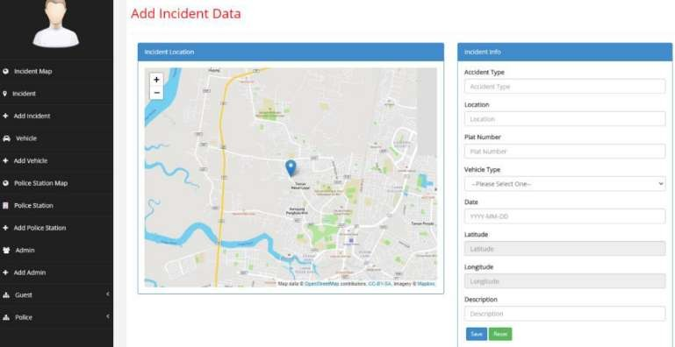Figure 2.4. Screenshot of the web-based GIS incident-reporting interface.[FIGURE 2.5 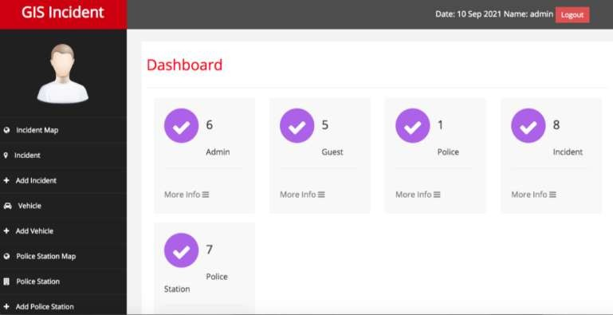
Figure 2.5. Screenshot of the web-based GIS administrative interface.

Advantages of Integrated GIS Traffic Incident Management (WGTIMS)
- Addressing a real-world problem: This research tackles an important issue the increasing number of road traffic accidents in communities and the need for a better traffic incident management system. The study explains why traditional methods are no longer sufficient and proposes a Web-GIS solution to improve emergency response and decision-making. Why this is an advantage; solves a practical problem, has potential to improve public safety, and supports government efforts to reduce road accidents.
- The major contribution of this research is the integration of Geographic Information Systems (GIS). Users can view accident locations on maps, identify accident hotspots, and improve situational awareness. This gives users better visualization, faster decision making, and easier resource allocation.
- The use of open-source technologies: The researchers developed the system using PHP, MySQL, Leaflet.js, and XAMPP. These are open-source technologies, making the system relatively inexpensive to build and maintain. This reduces development cost, easy to customize, and accessible to educational institutions and government agencies.

Disadvantages
- Most traffic incidents are reported by people using smartphones. The system is web-based only, and the authors recognize mobile support as future work. This may reduce convenience for field users.
- Limited security features: The paper implements role-based authentication but notes that features such as data encryption are planned for future work rather than currently implemented. Thing like sensitive accident data may not be fully protected and cybersecurity could be improved.
- The system runs on XAMPP using local hosting not suitable for nationwide deployment without further infrastructure. Scalability under heavy traffic was not demonstrated.

The CIRS adopts the useful principle of geospatial visualisation but expands the incident scope beyond traffic events. It includes fire, crime, medical, flooding/disaster, infrastructure, and general community incidents. It also adds a mobile application, anonymous reporting, response-team operation, status history, media records, public announcements, feedback, analytics, and audit functions.

2.3 Strengths and Limitations of Existing Approaches
Existing digital incident reporting systems commonly offer three major benefits: they can increase location accuracy by capturing GPS coordinates or enabling map-based location selection; they can improve the completeness of reports by collecting categories, descriptions, timestamps, and evidence; and they can make incidents visible through interactive maps and dashboards.
However, common limitations include narrow incident scope, inadequate verification mechanisms, poor handling of malicious or duplicate reports, limited privacy controls, weak response-team integration, absence of citizen feedback, insufficient operational auditability, and dependence on internet connectivity.
The CIRS is designed to respond to these limitations through integrated functions rather than isolated reporting features. It combines reporting, verification, dispatch, response tracking, mapping, feedback, analytics, and auditing in one architecture.

2.4 Justification for the Proposed System
The literature and reviewed systems show that community reporting, mobile devices, web platforms, and GIS are useful components of digital incident management. However, the reviewed approaches do not always provide a unified workflow for multiple incident categories and multiple operational roles.
The CIRS is justified because it supports incidents relevant to the Accra Metropolitan Area, including flooding, crime, infrastructure faults, fires, medical emergencies, and other safety hazards. It provides different functions to each role: citizens report and track incidents; administrators verify and dispatch incidents; response teams acknowledge, act, and resolve; and super administrators manage system-level controls and inspect audit records.
The system is also justified by its emphasis on accountability. Status histories, team assignments, updates, feedback, and audit logs create records that can help show what happened to a report after submission. This makes the platform more than a map of complaints; it is a structured incident-management and response-support system.

2.5 Chapter Summary
This chapter reviewed community incident reporting systems, citizen participation, GIS, mobile and web platforms, incident verification, usability, and security. It also considered three related systems retained from the original report. The review establishes that the proposed system is appropriate because it combines geospatial reporting with a controlled operational workflow, multi-platform access, role-based permissions, mapping, analytics, and accountability mechanisms.

CHAPTER THREE

SYSTEM ANALYSIS, DESIGN AND METHODOLOGY

3.0 Overview
This chapter presents the methodology, system requirements, user roles, modelling diagrams, workflow, architecture, database design considerations, and security measures for the Geospatial Community Incident Reporting and Response System. The chapter explains how the system was designed to support reporting, verification, dispatch, field response, status tracking, mapping, analytics, feedback, and auditability.

3.1 Development Methodology
The study adopted an Agile software development approach. Agile supports iterative development, regular evaluation, incremental delivery, and adaptation when requirements become clearer during implementation. Scrum is a widely used Agile framework that emphasises delivering value in small increments and reviewing progress regularly (Schwaber & Sutherland, 2020).
Agile was appropriate for this project because the system contained several connected modules: authentication, user and role management, incident reporting, geospatial mapping, administration, response-team operations, analytics, media management, announcements, feedback, and auditing. Developing these functions in iterations made it possible to build, test, refine, and integrate each module progressively.
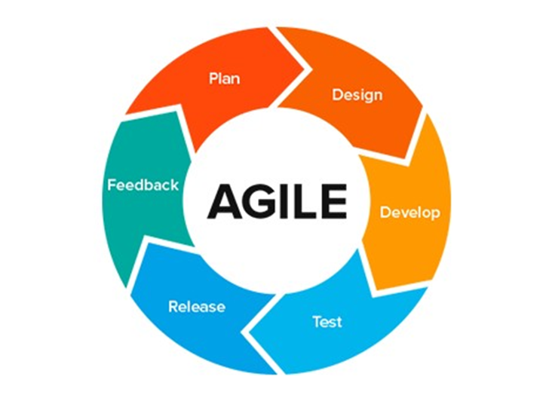
Figure 3.1 Image of Agile Development Methodology

3.1.1 Development Iterations
- Requirements analysis: Identification of stakeholders, incident categories, user roles, workflows, functional requirements, non-functional requirements, and data entities.
- System and database design: Preparation of use cases, workflow diagrams, architecture, database relationships, API design, and interface concepts.
- Authentication and role management: Development of registration, login, token authentication, role permissions, user profiles, and access restrictions.
- Incident reporting: Development of anonymous and authenticated reporting forms with category, severity, location, address, description, and media fields.
- Geospatial integration: Addition of map views, incident markers, filters, location capture, and location-selection features.
- Administrative workflow: Development of verification, rejection, duplicate handling, dispatch, status management, team management, user management, announcements, analytics, and export functions.
- Response-team workflow: Development of assigned-incident lists, acknowledgement, progress updates, evidence upload, and resolution processes.
- Testing and refinement: Functional testing, role-access testing, form validation testing, workflow testing, interface review, and improvement of identified issues.

3.2 Requirements Analysis

3.2.1 Stakeholders
- Citizen Reporters: Community members who submit incidents, track personal reports, view appropriate public information, and provide feedback.
- Anonymous Reporters: Members of the public who submit reports without creating or using an account.
- Response Teams: Personnel assigned to Fire, Police, Medical, Flood/Disaster, or General response teams.
- Administrators: Personnel who verify, manage, dispatch, update, and close incident records.
- Super Administrators: Personnel with broader system-management rights, including audit-log access and role-management oversight.
- Community planners and decision makers: Users who may interpret authorised analytics and mapped trends for planning purposes.

3.2.2 Functional Requirements
Code | Functional requirement
FR1 | The system shall allow users to register, log in, log out, reset passwords, and manage profiles.
FR2 | The system shall allow anonymous users to submit incidents without authentication.
FR3 | The system shall allow authenticated users to submit incident reports.
FR4 | The system shall capture incident title, category, description, severity, incident date, address, latitude, longitude, and media attachments.
FR5 | The system shall support incident categories such as Fire, Crime, Medical, Infrastructure, Flood/Disaster, and General.
FR6 | The system shall support severity levels of low, medium, high, and critical.
FR7 | The system shall generate a unique reference number for each incident report.
FR8 | The system shall allow administrators to view, filter, search, verify, reject, classify, and mark duplicate reports.
FR9 | The system shall allow administrators to assign or reassign verified incidents to response teams.
FR10 | The system shall notify or expose assigned incidents to relevant response teams.
FR11 | The system shall allow response teams to acknowledge assigned incidents.
FR12 | The system shall allow response teams to post field updates and upload response evidence.
FR13 | The system shall allow response teams to mark incidents as resolved.
FR14 | The system shall allow administrators to close resolved incidents or update statuses where appropriate.
FR15 | The system shall allow authenticated reporters to view the status history of their incident reports.
FR16 | The system shall allow authenticated reporters to submit feedback and ratings after incident handling.
FR17 | The system shall display appropriate incident markers on public and administrative maps.
FR18 | The system shall filter map and dashboard data by status, category, severity, and other relevant attributes.
FR19 | The system shall provide analytical summaries, including incident status distributions, category distributions, resolution information, and team performance indicators.
FR20 | The system shall enable authorised administrators to manage users, teams, categories, announcements, and selected system settings.
FR21 | The system shall record important actions in an audit log accessible to authorised super administrators.

3.2.3 Non-Functional Requirements
Category | Requirement
Usability | The interface should use clear labels, logical navigation, readable status indicators, validation messages, and role-specific dashboards.
Performance | The system should return common requests, such as loading incident lists and submitting forms, within acceptable time under prototype-level operating conditions.
Reliability | The system should preserve validated incident records and maintain a traceable history of status changes and updates.
Security | The system should use token-based authentication, role-based access control, request validation, rate limiting, and audit logging.
Privacy | Sensitive details, internal notes, and restricted incident information should be visible only to authorised roles.
Availability | The system should be available when its server, network, database, map services, and storage services are operational.
Maintainability | The system should use a modular architecture that separates client interfaces, API controllers, business services, models, database migrations, and storage.
Scalability | The architecture should permit migration from development storage to production-ready database and media-storage services where required.
Compatibility | The platform should support modern web browsers and mobile devices capable of running the relevant mobile application.
Auditability | Material administrative and system actions should be recorded to support monitoring and accountability.

ISO 9241-11 identifies effectiveness, efficiency, and satisfaction as central usability outcomes, while the system’s role-oriented interfaces are intended to support these outcomes for different user groups (ISO, 2018).

3.3 Use-Case Model
The use-case model identifies the main interactions between actors and the system.
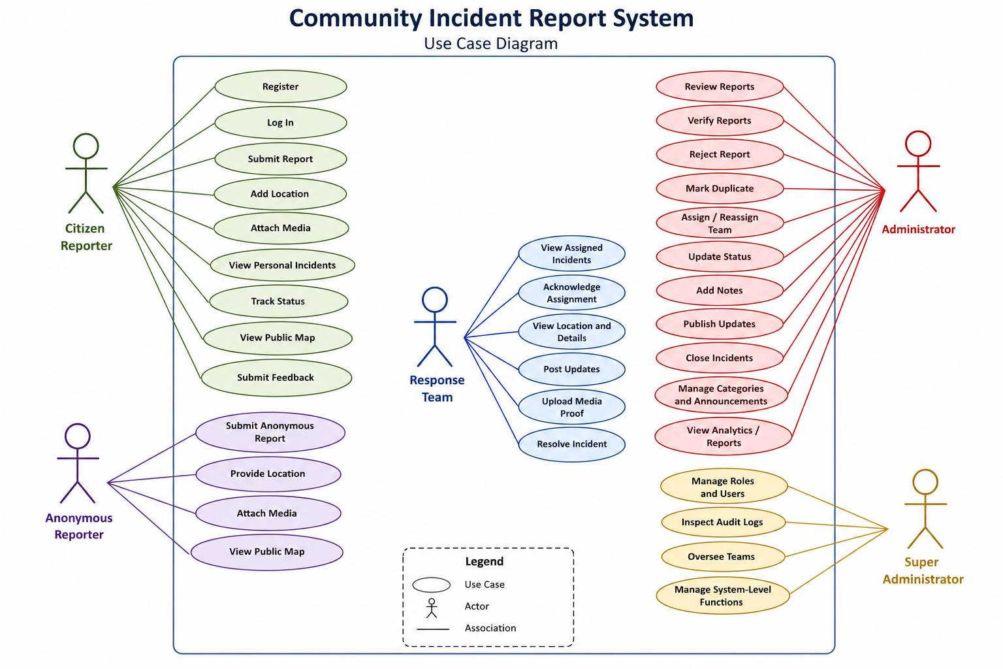
Figure 3.2. Use-case diagram for the Community Incident Reporting System.
Actor | Main use cases
Citizen Reporter | Register, log in, submit report, add location, attach media, view personal incidents, track status, view public map, submit feedback.
Anonymous Reporter | Submit anonymous report, provide location, attach media, view public map.
Response Team | View assigned incidents, acknowledge assignment, view location and details, post updates, upload media proof, resolve incident.
Administrator | Review reports, verify, reject, mark duplicate, assign or reassign team, update status, add notes, publish updates, close incidents, manage categories and announcements, view analytics.
Super Administrator | Manage roles and users, inspect audit logs, oversee teams, manage system-level functions.

3.4 Incident Reporting and Response Workflow
The incident workflow begins when a citizen or anonymous user submits an incident report. The report contains structured details including category, severity, description, geolocation, address, and optional media evidence. The system creates a record with an initial pending status.
An administrator reviews the submission. Where the report is insufficient, false, unsuitable, or invalid, it may be rejected with an appropriate reason. Where it duplicates an existing record, it may be marked as a duplicate. Where the report is valid, it moves through review and is assigned to an appropriate response team.
The assigned team acknowledges the dispatch, accesses the incident details and location, carries out response activities, adds operational updates, and uploads evidence where necessary. The team can then mark the incident as resolved. An administrator reviews the resolution and closes the incident when appropriate. Authenticated reporters may subsequently provide feedback.
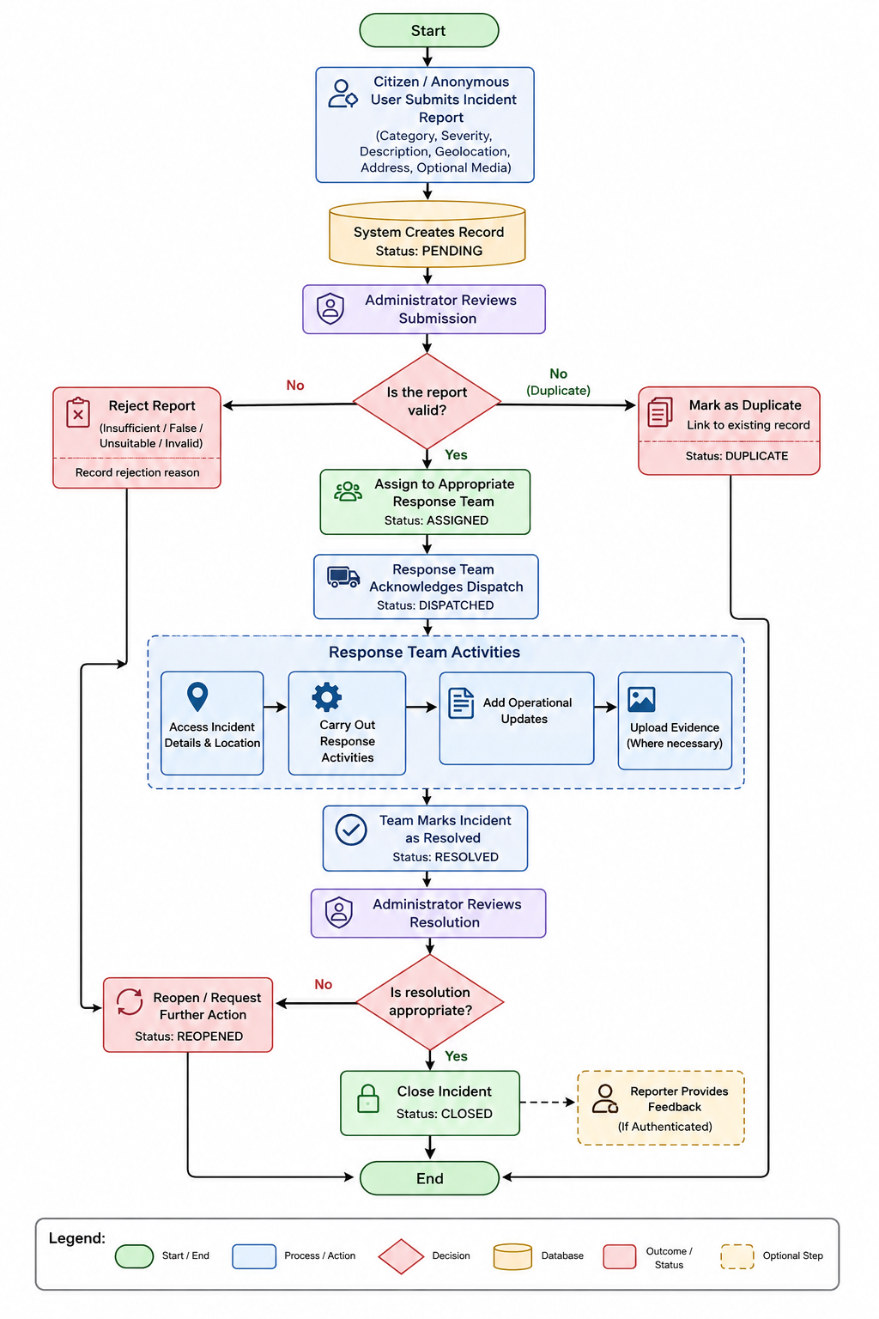
Figure 3.2. Incident reporting, verification, dispatch, response, and closure flowchart.
- Citizen Reporter or Anonymous Reporter submits incident.
- System validates required information and creates a pending record.
- Administrator reviews the report.
- Administrator rejects, marks duplicate, or verifies the report.
- Verified incident is assigned to a specialised response team.
- Response Team acknowledges the assignment.
- Response Team posts updates and uploads supporting evidence.
- Response Team marks incident as resolved.
- Administrator reviews and closes the incident.
- Authenticated Citizen Reporter submits feedback, where applicable.
- The system retains status history and audit records.

3.5 System Architecture
The system uses a three-tier architecture comprising the client layer, application/API layer, and data-storage layer. This structure separates user interfaces from business logic and persistence functions, making the system easier to maintain and extend.
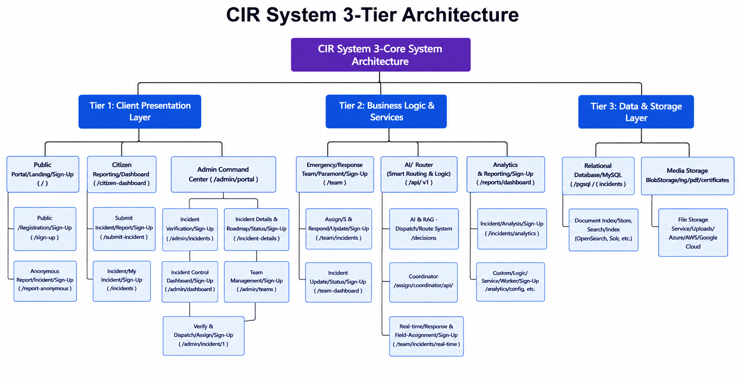
Figure 3.3. Three-tier architecture of the Geospatial Community Incident Reporting and Response System.

3.6 Data Model Design
Entity | Purpose
User | Stores reporter, administrator, response-team, and super-administrator account details.
Role | Defines access privileges for Reporter, Response Team, Administrator, and Super Administrator.
Incident | Stores the main report record, including reference number, category, severity, status, location, address, dates, reporter details, notes, and duplicate information.
Incident Category | Defines allowable reporting categories, such as Fire, Crime, Medical, Infrastructure, and Flood/Disaster.
Team | Stores specialised response-team information.
Team Member | Associates users with one or more response teams.
Incident Assignment | Records the dispatch of an incident to a team, acknowledgement time, work status, and assignment activity.
Incident Update | Stores progress updates from administrators or response teams.
Incident Status History | Maintains a chronological record of significant status changes.
Incident Media | Stores metadata for attached image, video, or document evidence.
Feedback | Stores authenticated reporter ratings and comments following incident management.
Announcement | Stores public notices, warnings, or emergency messages.
Audit Log | Records significant system actions for oversight and accountability.

The data model supports traceability by separating the incident’s main record from assignments, updates, histories, media, feedback, and audit information.

3.7 Security Design
- Authentication: Protected API functions require a valid bearer token issued through Laravel Sanctum.
- Authorisation: Role-based middleware restricts functions according to user role and permission.
- Input validation: Backend requests and frontend form schemas validate key fields, including location coordinates and accepted media types.
- Rate limiting: Selected public authentication routes are throttled to reduce brute-force or abusive requests.
- Audit logging: Important actions are recorded with user, action, timestamp, IP address, user-agent information, and relevant state information.
- Role-protected routing: The web and mobile clients restrict access to screens that do not match a user’s assigned role.
These measures improve the prototype’s security posture, but a production deployment would require further controls such as HTTPS enforcement, secure secrets management, encryption strategy, backup and recovery testing, application monitoring, vulnerability assessment, and compliance with applicable data-protection requirements.

3.8 Testing Strategy
Test type | Example
Unit testing | Validate discrete functions such as category validation, report status transitions, and reference-number generation.
Integration testing | Confirm that the web or mobile client communicates correctly with the API, database, media storage, and mapping components.
Functional testing | Confirm that users can register, log in, submit reports, attach media, update status, assign teams, and resolve incidents.
Role-based access testing | Confirm that each role sees only authorised pages and can perform only permitted actions.
Validation testing | Confirm that invalid inputs, incomplete forms, unsupported media, and invalid coordinates are handled appropriately.
Workflow testing | Confirm the end-to-end lifecycle from report submission to closure and feedback.
Usability testing | Observe whether representative users can complete core tasks clearly and efficiently.
Security testing | Check authentication, authorisation, session handling, input validation, rate limiting, and audit-log behaviour.
Performance testing | Measure response behaviour under realistic prototype-level requests and identify potential bottlenecks.

3.9 Chapter Summary
This chapter presented the methodology and design of the CIRS. An Agile approach was selected because the system was developed incrementally across connected modules. The chapter defined stakeholders, functional requirements, non-functional requirements, use cases, workflow, architecture, data entities, security measures, and testing activities. The next chapter should present the system implementation, user interfaces, test results, and discussion of findings.

CHAPTER FOUR

SYSTEM IMPLEMENTATION, TESTING AND EVALUATION

4.0 Overview
This chapter presents the implementation of the Geospatial Community Incident Reporting and Response System (GCIRRS) for the Accra Metropolitan Area. It explains the technologies, software components, data structures, user interfaces, operational workflow, security measures, and testing carried out to translate the design described in Chapter Three into a functional multi-platform system.
The implemented GCIRRS is not limited to a conventional web-based incident-reporting form. It provides a coordinated workflow in which citizens can submit anonymous or authenticated reports, administrators can verify and dispatch incidents, specialized response teams can acknowledge assignments and provide field updates, and authorized users can monitor incident status, mapping information, analytics, feedback, and audit trails. The system addresses incident categories such as flooding, crime, fire, medical emergencies, infrastructure faults, natural disasters, and other community safety concerns.

4.1 Implementation Environment
The GCIRRS was implemented as a decoupled three-tier system consisting of a web client, mobile client, RESTful API backend, relational database, and media storage layer. This implementation approach separates user-interface concerns from business logic and data persistence, making the system easier to maintain and extend.

4.1.1 Development Tools and Technologies
Component | Technology | Purpose
Web frontend | React 19, Vite, Tailwind CSS | Responsive browser-based interface for citizens, teams, administrators, and super administrators
Mobile application | React Native, Expo SDK, Expo Router | Mobile experience for reporting, GPS capture, evidence capture, and field response updates
Backend API | Laravel 11, PHP 8.2 | RESTful API, business logic, validation, workflow management, and service layer
Authentication | Laravel Sanctum | Token-based API authentication
Authorisation | Spatie Laravel-Permission | Role and permission control for Reporter, Response Team, Administrator, and Super Administrator
Database | SQLite for development; MySQL 8-compatible deployment | Storage of structured application records
Mapping | Leaflet and React-Leaflet | Interactive map display, markers, filters, and location selection
State management | Zustand | Client-side state management
Form validation | React Hook Form and Zod | Web form handling and validation
HTTP communication | Axios | Communication between clients and the API
Analytics | Recharts | Charts for incident status, category distribution, response performance, and related summaries
Mobile device services | Expo Location and Expo Image Picker | GPS coordinate capture and camera/gallery media selection
Media storage | Local/public storage or S3-compatible storage | Incident and response media storage
Development environment | Visual Studio Code, Node.js, Composer, Expo CLI | Source development, package management, and mobile development

The web and mobile applications communicate with the same Laravel API through JSON-based HTTP requests. This ensures that all user roles operate on a shared incident record rather than separate databases or disconnected interfaces.

4.1.2 Web Application Implementation
The web application was implemented with React and Vite. React supports a component-oriented design in which reusable interface elements such as navigation bars, forms, tables, modals, badges, timelines, maps, and dashboards can be organised by function. Tailwind CSS was used to provide responsive styling and consistent interface elements.
The web application contains public pages and protected role-specific pages. Public pages include the landing page, public incident map, announcements, login, registration, password recovery, and anonymous reporting pages. Protected pages are organised into Reporter, Response Team, Administrator, and Super Administrator sections. Route guards ensure that a user cannot access functions that are outside the user’s assigned role.

4.1.3 Mobile Application Implementation
The mobile application was implemented with React Native and Expo. The mobile design supports users who report incidents or carry out field activities while away from a desktop computer. The application uses file-based navigation through Expo Router and redirects authenticated users to the appropriate Reporter, Response Team, or Administrator section according to their assigned role.
The mobile application supports GPS-based location capture through Expo Location. A citizen or field responder can obtain device coordinates to improve the accuracy of an incident location. The application also uses Expo Image Picker to allow users to capture photographs with a device camera or select images from the gallery as evidence. Authentication state is cached locally using AsyncStorage to improve session continuity across application launches.

4.1.4 Backend Implementation
The backend was implemented with Laravel 11 and PHP 8.2. It provides a RESTful API under the /api/v1 route structure. The backend is organized using API controllers, models, middleware, policies, service classes, migrations, seeders, and route definitions. The service layer includes modules for incident management, analytics, auditing, media handling, and notifications.
The backend applies validation before storing reports and uses role middleware to restrict administrative and response-team actions. For example, only an Administrator or Super Administrator can verify a pending report, assign a response team, or manage system users. Only the assigned response team can acknowledge an assigned incident, post field updates, upload response evidence, or mark the incident as resolved.

4.2 Database Implementation

4.2.1 Database Structure
The system uses SQLite as the default development database and supports MySQL 8-compatible deployment for broader use. The database is structured around core entities that represent users, roles, incidents, incident categories, teams, dispatches, progress updates, status histories, media files, feedback, announcements, notifications, and audit activity.
Entity | Main purpose
User | Stores account and profile information, including name, email, phone number, password, profile photo, active status, and verification information
Role and permission | Defines access levels for Super Administrator, Administrator, Response Team, and Reporter
Incident | Stores the central incident record, including title, description, category, severity, status, location, address, incident date, timestamps, notes, and duplicate-report information
Incident category | Stores category definitions such as Fire, Crime, Medical, Infrastructure, Natural Disaster, and General
Team | Stores response-team details, including team name, description, team type, and active status
Team member | Links response-team users to teams and identifies team leaders
Incident assignment | Records dispatch from an administrator to a response team, including assignment, acknowledgement, and completion information
Incident update | Stores field and administrative progress updates
Incident status history | Maintains a timeline of incident-status changes
Incident media | Stores file metadata for images, videos, and documents attached to incident records
Feedback | Stores ratings and comments submitted by authenticated reporters after handling of an incident
Announcement | Stores public information, warning, or emergency announcements
Audit log | Records important system actions, including user, action, model, timestamp, IP address, and state changes

The Incident entity is the core of the database. It includes a unique reference number, such as INC-YYYYMMDD-XXXX, which helps identify an incident throughout the workflow. Incidents can be anonymous or linked to an authenticated reporter. Each incident has a category, severity level, status, latitude, longitude, human-readable address, timestamps, administrative notes, media, assignments, updates, history, and feedback relationships.

4.2.2 Incident Status Lifecycle
Status | Meaning
Pending | The report has been submitted and awaits administrative review
Under review | The report is being assessed or verified
Assigned | The incident has been allocated to an appropriate response team
In progress | The assigned team has acknowledged or begun active response
Resolved | The response team has completed its reported action
Closed | The administrator has formally completed the incident record
Rejected | The report was not accepted, with a recorded reason where applicable
Duplicate | The report is linked to an existing incident to avoid repeated handling

The separation between resolution and closure is important. A response team can report that its field work is complete, while the administrator retains authority to review the action, add notes, and close the record. This provides a clearer accountability trail.

4.2.3 Data Integrity and Validation
Data integrity is supported through database relationships, Laravel migrations, request validation, and frontend form validation. The system validates required values such as incident title, category, severity, description, location information, and accepted media types. It also checks latitude and longitude bounds to reduce invalid location records.
Authentication data, role details, incident records, assignments, updates, and feedback are stored in related tables rather than duplicated across unrelated records. This structure reduces redundancy and supports efficient querying, filtering, analytics, and audit functions.
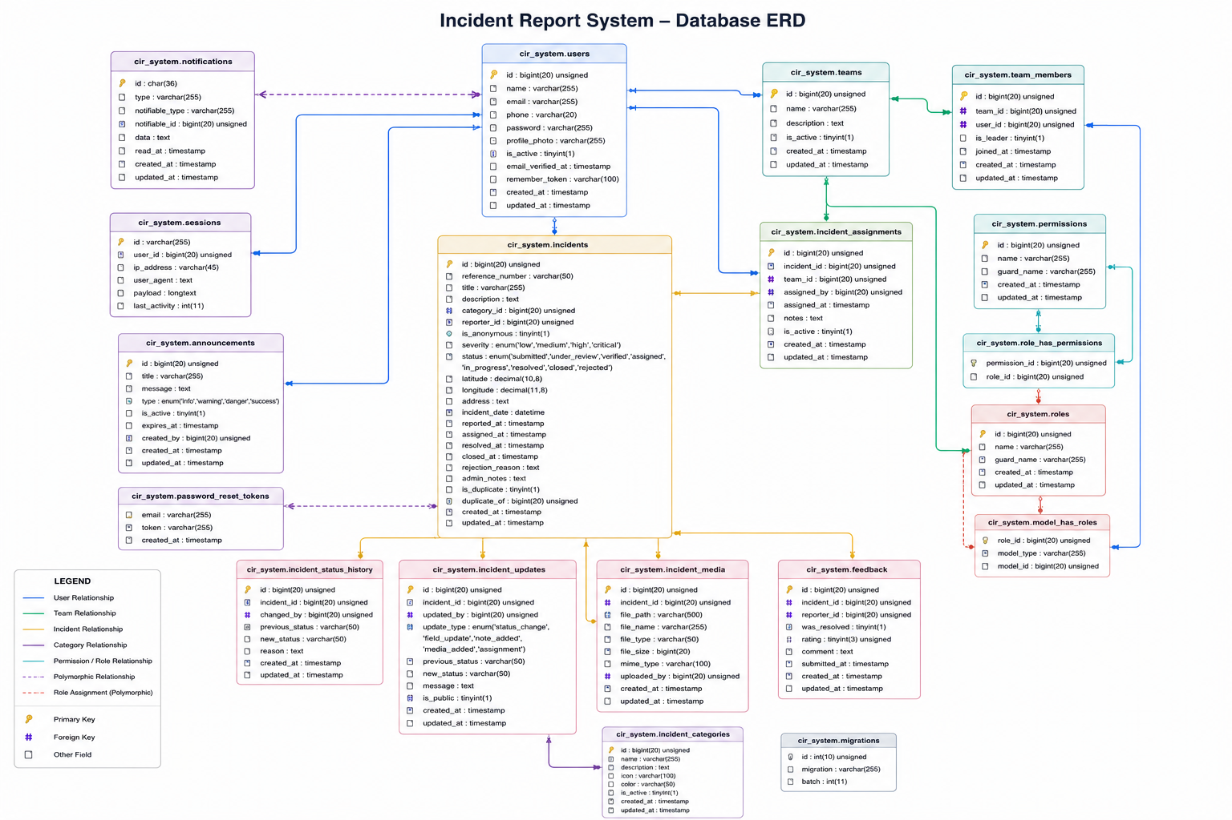
Figure 4.1. Entity Relationship Diagram of the Geospatial Community Incident Reporting and Response System.
The revised ERD should include at minimum: User, Role, Incident, Category, Team, Team Member, Incident Assignment, Incident Update, Incident Status History, Incident Media, Feedback, Announcement, and Audit Log.

4.3 System Modules and Interfaces

4.3.1 Authentication and Account Management
The system provides registration, login, profile management, password recovery, and token-based authentication. New users can create Reporter accounts, while authorised administrators can manage user roles and account status. Protected API requests include authentication tokens, while role middleware prevents users from performing functions outside their permissions.
The registration interface captures a user’s name, email address, phone number, password, and password confirmation. Validation messages are shown where required information is missing or invalid. The login interface allows registered users to enter their email address and password before accessing their role-specific dashboard.
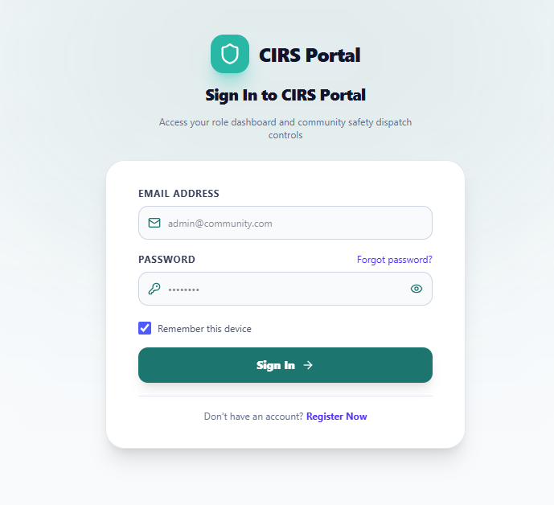
Figure 4.2. Login interface.
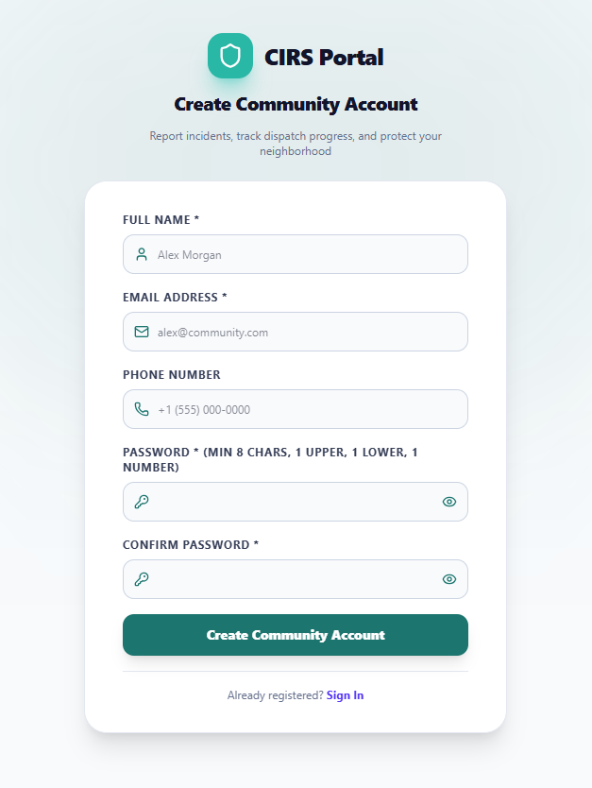
Figure 4.3. User registration interface.

4.3.2 Anonymous Incident Reporting
A significant feature of the system is anonymous incident reporting. It enables a person to report a community issue without creating an account or disclosing identity through the standard user profile process. This option is particularly relevant to incidents where a reporter may fear exposure, such as crime, public-safety threats, or sensitive community concerns.
An anonymous report still requires useful operational information: title, category, severity, description, location, address where available, and optional evidence files. The report enters the same administrative verification workflow as an authenticated report. The anonymous-reporting function therefore improves accessibility but does not remove the need for validation, verification, duplicate handling, or responsible dispatch.

4.3.3 Citizen Reporter Dashboard
Authenticated Citizen Reporters access a dashboard that provides an overview of their submitted reports, current incident statuses, notifications, and quick access to emergency contacts. The dashboard enables users to submit a new report, view the details of existing reports, track status updates, and provide feedback after the handling of an incident.
The incident-report form is designed as a multi-step interface. It includes a title field, category selection, severity selection, description, incident-date information, address geocoding, a Leaflet map with adjustable location pin, and a multiple-file uploader for relevant evidence. This design helps users submit standardized reports that can be reviewed and acted upon by administrators.
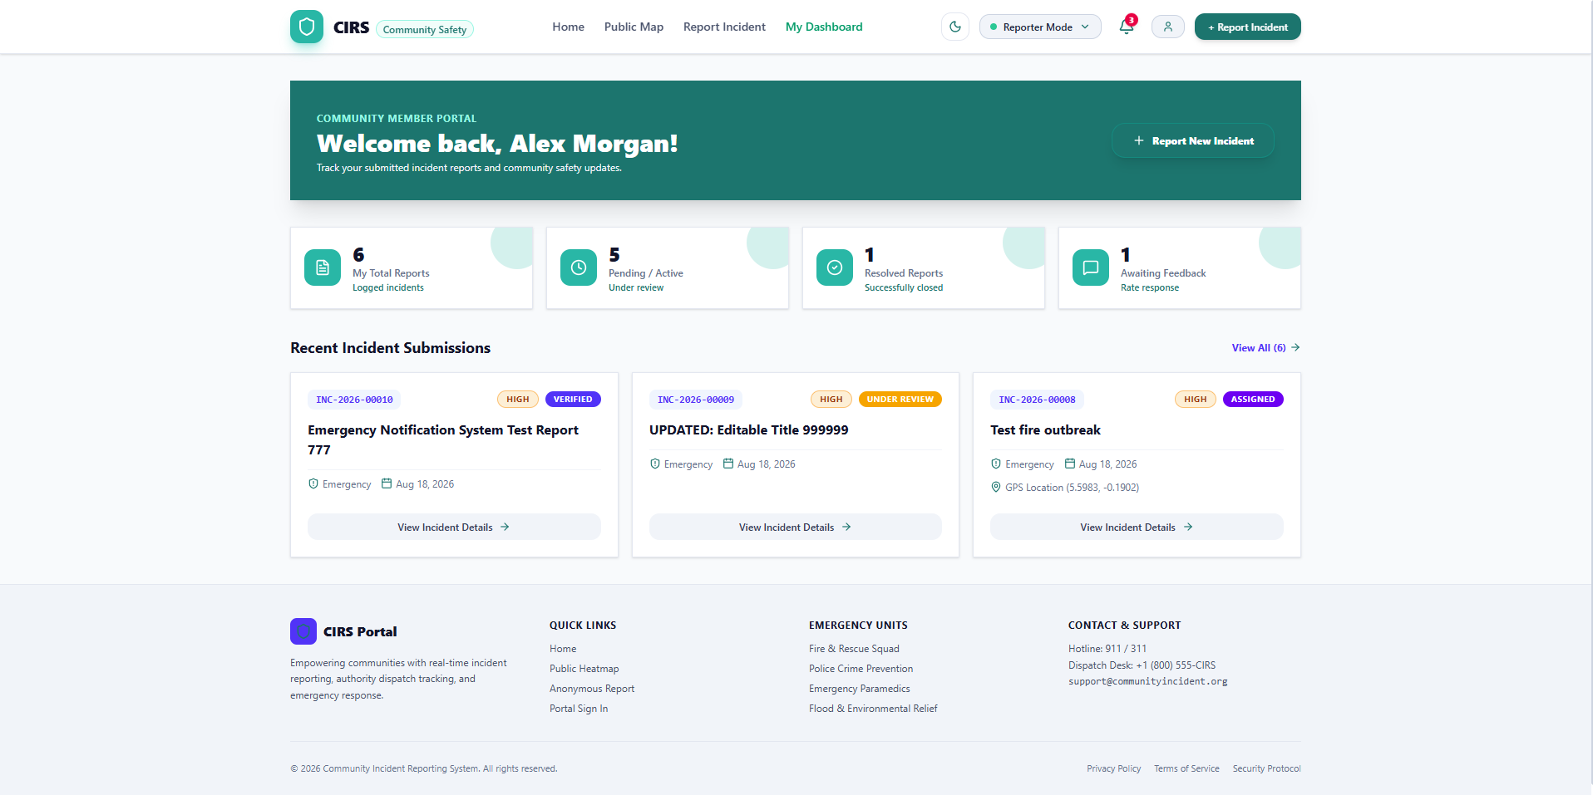
Figure 4.4. Citizen incident reporting interface with category, severity, location, description, and media fields.

4.3.4 Public Map and Geospatial Visualization
The GCIRRS provides an interactive public map that displays non-confidential, verified, and resolved incidents as appropriate. Map markers can be filtered by incident category, severity, and status. This feature contributes to public awareness while allowing the system to protect restricted operational information from unauthorized users.
The administrative map provides broader visibility for authorized decision makers. Administrators can use map markers, filters, category information, severity levels, date ranges, and incident statuses to assess the distribution of incidents. This supports monitoring of flooding, crime, infrastructure faults, fire incidents, medical emergencies, and other community issues across the study area.
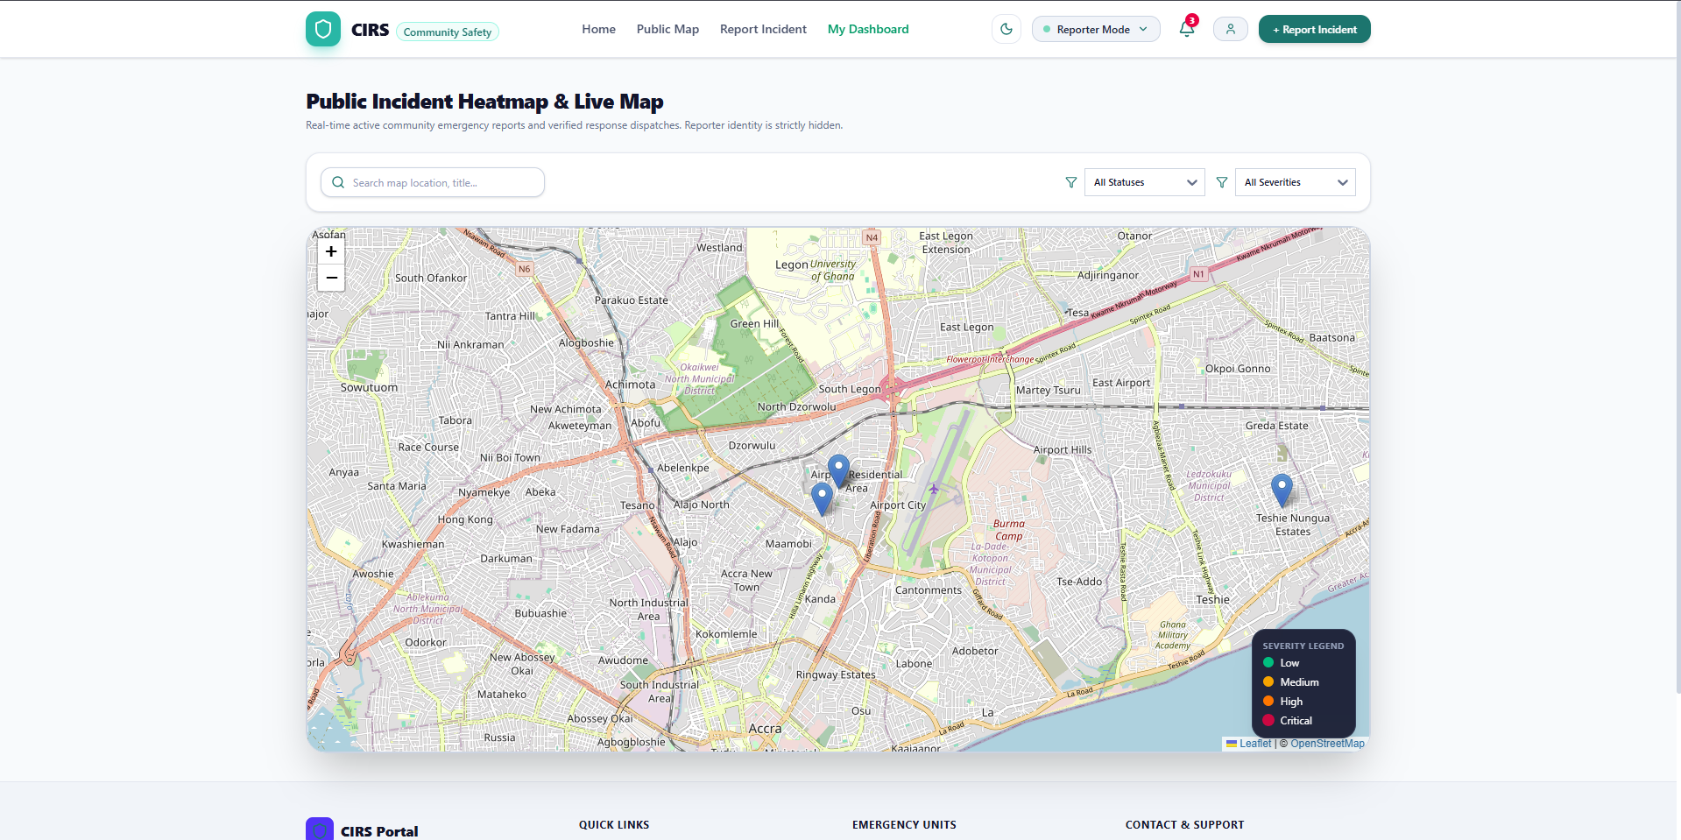
Figure 4.5. Interactive geospatial incident map with filtering options.

4.3.5 Response Team Dashboard
Response Teams have dedicated dashboards and operational pages for managing incidents assigned to their respective units. The system supports specialized response-team categories, including Fire, Police, Medical, Flood/Disaster, and General response teams.
A response-team member can view the queue of assigned incidents, access incident details and geographic location, acknowledge dispatch, post updates from the field, upload photographs or other evidence, and mark work as resolved. The incident-response page provides a location view, operational timeline, update form, media-proof interface, and resolution function.
This module ensures that reporting does not end at the administrative review stage. It establishes a controlled path from report verification to actual response-team activity and documented resolution.
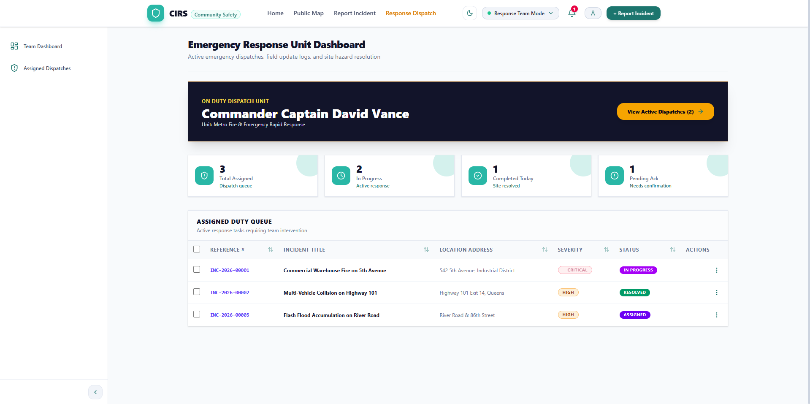
Figure 4.6. Response Team dashboard and assigned-incident interface.

4.3.6 Administrator Dashboard
The Administrator dashboard is the main command interface for incident management. It provides counts of active incidents, pending verification items, emergency status, quick dispatch actions, and analytical summary widgets.
Administrators can access an incident-management table with search and filtering functions based on category, severity, status, date range, and duplicate status. An administrator can verify a report, reject it with a reason, add notes, mark it as duplicate, assign or reassign a response team, publish an update, change status, close a record, and export selected records to CSV.
The dashboard also includes user management, response-team management, category management, announcement management, analytics, and system notifications. These functions enable administrators to manage the operational environment rather than only individual incident records.
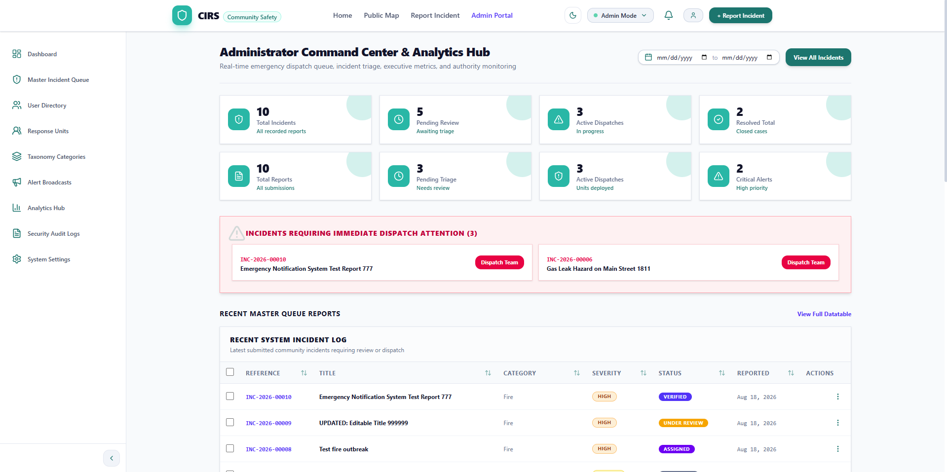
Figure 4.7. Administrator dashboard for verification, dispatch, monitoring, and analytics.

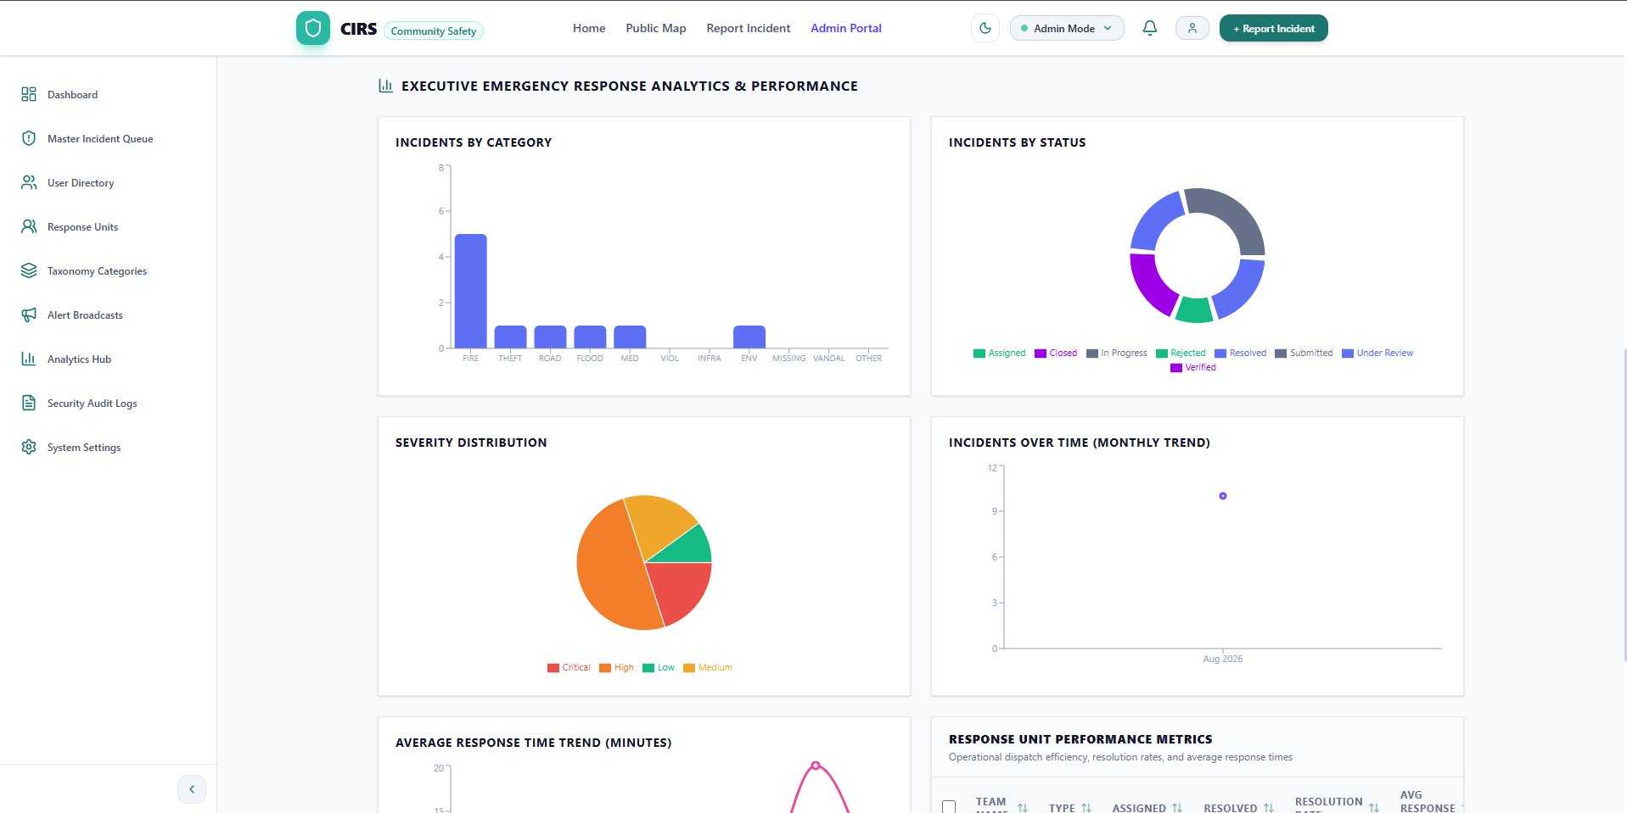
Figure 4.8. Administrator dashboard for verification, dispatch, monitoring, and analytics.

4.3.7 Super Administrator Functions
The Super Administrator has a broader oversight role than a standard administrator. In addition to selected administrative functions, the Super Administrator can inspect audit logs and manage system-level access, user roles, teams, and operational controls.
The audit log is particularly important for accountability. It records system actions together with relevant user, timestamp, IP address, user-agent, affected model, and state-change information. This creates a traceable history of important administrative and system events.

4.3.8 Analytics and Announcements
The Analytics Centre provides charts and summary indicators for incident status, category distribution, team performance, response-related information, and other aggregate measures. Recharts is used to display bar, pie, and area charts. These visualisations can help administrators identify patterns and assess operational workload.
The Announcement module allows authorised administrators to create public messages with types such as information, warning, and emergency. Active announcements appear across web and mobile interfaces, enabling the platform to communicate public-safety information in addition to receiving incident reports.

4.4 Security Implementation
- Laravel Sanctum bearer tokens are used for authenticated API access.
- Spatie role and permission middleware restricts sensitive functions to authorised roles.
- Public authentication routes use rate limiting to reduce brute-force attempts.
- Laravel request validation and frontend Zod schemas validate user input.
- Geographic coordinates and media-file types are validated before storage.
- Role-protected routes prevent users from accessing incompatible dashboards.
- Audit logs record significant system actions and changes.
- Administrative functions, such as user management, dispatch, verification, audit-log access, and closure, are restricted according to role.
The implemented controls improve the security posture of the prototype. However, a production deployment would require additional measures including HTTPS enforcement, server hardening, secure backups, disaster recovery, encryption strategy, vulnerability scanning, privacy-impact assessment, audit-log monitoring, and independent penetration testing.

4.5 Testing and Results

4.5.1 Testing Approach
Testing was carried out throughout development to verify functional requirements, role permissions, workflow integration, validation behaviour, and user-interface flow. The focus was on confirming that a report could progress correctly from submission to closure and that no role could perform restricted activities.
- Authentication testing.
- Form-validation testing.
- Incident-submission testing.
- Anonymous-reporting testing.
- Media-upload testing.
- GPS and map-location testing.
- Role-based authorization testing.
- Administrator verification and dispatch testing.
- Response-team acknowledgement, update, and resolution testing.
- Status-history and audit-log testing.
- Dashboard filtering and analytics testing.
- Web and mobile API-integration testing.

4.5.2 Functional Test Results
Test case | Expected result | Result
User registration | A Reporter account is created after valid details are submitted | Passed
User login | Valid credentials return authenticated access and route the user to the correct role interface | Passed
Anonymous reporting | A user can submit a report without a registered account | Passed
Authenticated reporting | An authenticated Reporter can submit an incident with structured details | Passed
Location capture | Incident latitude, longitude, and address data are stored for map display | Passed
Media upload | Supported image, video, or document evidence can be attached to an incident | Passed
Input validation | Incomplete, invalid, or unsupported entries are rejected with feedback | Passed
Report verification | Administrator can review and verify or reject a pending report | Passed
Duplicate handling | Administrator can mark an incident as duplicate and link it to an existing record | Passed
Team assignment | Administrator can assign a verified incident to the appropriate response team | Passed
Team acknowledgement | Assigned Response Team can acknowledge an incident | Passed
Field update | Response Team can post progress information and upload proof | Passed
Resolution | Response Team can mark an incident as resolved | Passed
Closure | Administrator can close a resolved incident | Passed
Feedback | Authenticated Reporter can submit a rating and comment after incident handling | Passed
Map filtering | Users can filter map incidents by relevant status, category, and severity information | Passed
Access control | Restricted functions are blocked for unauthorized roles | Passed
Audit logging | Significant actions are captured for Super Administrator review | Passed

The results indicate that the main workflow was implemented successfully: submission, verification, assignment, acknowledgement, response update, resolution, closure, and feedback. The test results demonstrate system functionality, but they should not be interpreted as evidence of operational effectiveness in a live emergency environment because the project remains an academic prototype.

4.5.3 Objective Achievement
Objective | Evidence of achievement
Analyze community incident-reporting challenges | Requirements and workflow were designed around fragmented reporting, poor location precision, limited tracking, and inadequate accountability
Design a role-based architecture | The system implements Reporter, Response Team, Administrator, and Super Administrator roles
Develop web and mobile reporting interfaces | React web and React Native mobile applications communicate through the same API
Support anonymous and authenticated reporting | Public anonymous-report endpoint and authenticated incident-reporting functions were implemented
Integrate geospatial reporting | GPS capture, address information, Leaflet maps, markers, filters, and location selection were implemented
Implement verification and dispatch | Administrators can verify, reject, mark duplicates, and assign teams
Support response-team operations | Teams can acknowledge, update, upload proof, and resolve incidents
Support transparency and accountability | Status history, feedback, announcements, analytics, and audit logs were implemented
Apply security measures | Token authentication, role-based authorization, rate limiting, validation, and audit logging were implemented

4.6 Chapter Summary
This chapter described the implementation of the GCIRRS as a web and mobile community incident-reporting and response platform. The system was built with React, React Native, Laravel, SQLite/MySQL-compatible storage, Leaflet mapping, token authentication, and role-based access control.
The implemented system supports the full lifecycle of an incident: anonymous or authenticated submission, structured evidence capture, geolocation, verification, rejection or duplicate handling, response-team assignment, acknowledgement, field updates, evidence upload, resolution, administrative closure, and citizen feedback. It further provides map-based visualization, dashboards, analytics, announcements, notifications, and audit logs. Functional testing confirmed that the main system modules and workflow performed according to the documented requirements.

CHAPTER FIVE

CONCLUSION, CHALLENGES AND RECOMMENDATIONS

5.0 Overview
This chapter presents the conclusions drawn from the development of the Geospatial Community Incident Reporting and Response System for the Accra Metropolitan Area. It summarises how the project responded to the problem identified in Chapter One, outlines the major insights gained from the implementation, presents the main challenges encountered, and recommends a roadmap for future research and development.

5.1 Summary
The project was motivated by the problem of fragmented, informal, location-ambiguous, and difficult-to-track community incident reporting. In the study context, flooding, crime, fire outbreaks, medical emergencies, infrastructure faults, and other public-safety hazards may be reported through phone calls, personal visits, informal messages, or social-media posts. These methods may not consistently provide accurate location data, incident categorization, severity information, media evidence, a response history, or feedback to the reporter.
The project therefore designed and developed the Geospatial Community Incident Reporting and Response System as a multi-platform solution that integrates citizen reporting, administrative review, response-team operations, mapping, analytics, and accountability functions. The system provides both anonymous and authenticated incident reporting, thereby supporting accessibility while also preserving a workflow for verification and operational review. It enables citizens to submit reports with category, severity, description, address, GPS coordinates, and multimedia evidence.
The implementation showed that a community reporting platform can be designed as an end-to-end workflow rather than merely as a digital complaint form. Reports move from pending submission through verification, rejection, duplicate handling, response-team assignment, acknowledgement, progress updates, resolution, and administrative closure. This workflow creates a clearer chain of responsibility among Citizen Reporters, Administrators, Response Teams, and Super Administrators.
A major conclusion from the project is that geospatial information is central to the usefulness of a community incident system. The combination of device GPS, address information, an adjustable map pin, interactive incident maps, and filtering by status, category, and severity supports better spatial awareness than unstructured location descriptions alone. For flooding, crime, infrastructure faults, fire, and medical incidents, accurate map-based information can assist authorized personnel to locate incidents, review their distribution, and identify possible areas of recurring concern.
The system also demonstrated the importance of separating public reporting from operational decision-making. Citizens can report incidents and monitor appropriate status information, but verification, dispatch, internal notes, and incident closure remain controlled by authorised users. This separation supports transparency without exposing sensitive operational details. The anonymous-reporting feature additionally shows that participation can be expanded for sensitive reports while retaining administrative safeguards such as validation, verification, rejection, and duplicate marking.
Another insight is that accountability depends on retaining the history of actions, not only the current state of an incident. The GCIRRS implements incident status histories, team assignments, updates, media evidence, feedback records, and audit logs. These features make it possible to examine what happened to an incident after it was reported and who performed significant actions during its lifecycle.
The project further established that a web-and-mobile architecture is appropriate for a system with different user contexts. The mobile application supports location capture, camera use, reporting, and field updates, while the web application supports larger dashboards, incident management, user management, analytics, maps, announcements, and audit review. This division allows the system to support both community-facing and administrative operations through one shared API and data model.
The broader implication of this work is that community incident management can be strengthened when citizens are treated as structured sources of local information and when that information is connected to verification, dispatch, response tracking, and decision-support tools. The system provides a foundation for future digital public-safety and emergency-management solutions in Accra and other communities. Nevertheless, the project remains a prototype. Its implementation demonstrates technical feasibility and workflow integration; it does not establish that the system has already reduced emergency-response times, crime, flooding, fire losses, or medical risk in a live operational setting.

5.2 Challenges
The project required the integration of web, mobile, backend, database, mapping, authentication, media-storage, and analytics components, making coordination of system modules challenging. Ensuring consistent data exchange between the React web application, React Native mobile application, and Laravel API required careful API design and validation. GPS accuracy and availability depended on device permissions, hardware, environmental conditions, and internet connectivity. Supporting anonymous reporting improved accessibility but introduced additional concerns about false, incomplete, malicious, or duplicate submissions. Designing role-based workflows required careful restriction of sensitive operations so that only authorised users could verify, dispatch, resolve, or inspect audit records. Handling incident media required validation of accepted files, storage paths, and relationships between files and incident records. The project was developed as an academic prototype, so extensive load testing, penetration testing, disaster-recovery testing, and production hosting validation were outside its scope. Access to representative operational users for long-term field evaluation was limited. The system also required an appropriate balance between public transparency and protection of sensitive incident and location information. Finally, formal institutional integration with emergency-response agencies was not implemented and would require policy, legal, operational, and technical collaboration.

5.3 Recommendations
Future work should focus on transforming the prototype into a robust, institutionally integrated, and empirically evaluated platform. The following roadmap identifies important questions and objectives that were not fully addressed in the present work.

5.3.1 Conduct Formal Usability and Acceptance Evaluation
The system should be evaluated with representative residents, administrators, emergency responders, and community stakeholders in the Accra Metropolitan Area. Future research should determine whether users can complete key tasks efficiently, including reporting an incident, selecting a category and severity, capturing a location, attaching media, verifying an incident, assigning a team, updating a response, and closing a record. This is significant because technical implementation alone does not guarantee adoption. A formal evaluation using usability measures, task-completion analysis, interviews, questionnaires, and user-observation sessions would identify barriers related to language, accessibility, digital literacy, interface clarity, trust, and willingness to report incidents.

5.3.2 Integrate With Official Emergency Services
Future development should explore formal integration with relevant emergency and public-safety institutions, such as the National Disaster Management Organization, Ghana National Fire Service, Ghana Police Service, National Ambulance Service, local assemblies, and utility or infrastructure agencies. This is significant because the current system models response teams within the prototype but does not establish live integration with official dispatch or emergency-command procedures. Integration could enable verified incidents to be escalated through approved institutional channels, subject to memoranda of understanding, data-sharing agreements, standard operating procedures, and legal approval.

5.3.3 Add Real-Time Communication and Notifications
The system should be enhanced with real-time notifications through push notifications, SMS, email, and in-application alerts. It should also support configurable escalation rules for critical incidents, such as large fires, severe flooding, life-threatening medical events, or high-risk crimes. This is significant because emergency reporting has time-sensitive requirements. Future research should evaluate which notification channels are reliable, affordable, accessible, and appropriate for different user groups and incident severity levels in the Accra context.

5.3.4 Strengthen False-Report and Duplicate Detection
Future versions should add more advanced tools for detecting misleading, malicious, incomplete, or duplicate reports. Possible techniques include duplicate-location checks, time-based similarity detection, image metadata checks, reporter reputation indicators for authenticated users, administrator review queues, and machine-learning-assisted classification. This is significant because resource diversion caused by false reports can undermine trust and delay attention to genuine incidents. Any automated detection approach should be carefully evaluated to avoid unfairly rejecting legitimate reports, especially anonymous or low-information reports from vulnerable users.

5.3.5 Improve Offline and Low-Connectivity Support
The mobile application should be extended to support offline incident drafting, queued uploads, delayed synchronization, and low-bandwidth modes. It should also provide clear user feedback when GPS, network, or media upload services are unavailable. This is significant because connectivity may be unreliable during severe weather, flooding, power interruptions, or in locations with limited mobile coverage. Offline-first design would improve the system’s usefulness in circumstances where incident reporting is most needed.

5.3.6 Expand GIS and Predictive Analytics
Future research should explore richer spatial-analysis functions, including hotspot analysis, heat maps, temporal trend analysis, flood-risk overlays, response-time mapping, route optimization, and geographic clustering. Where reliable data and ethical approval are available, predictive models could be investigated for identifying locations or periods with elevated incident risk. This is significant because the current system provides mapped incident records and dashboards, but it does not constitute a full spatial decision-support or predictive system. Advanced analytics could assist planning, prevention, resource allocation, and community-risk communication.

5.3.7 Conduct Security, Privacy, and Data-Protection Assessment
The system should undergo penetration testing, vulnerability assessment, security-code review, logging review, backup-and-recovery testing, and privacy-impact assessment before any public deployment. Future work should also determine how long reports, media, location coordinates, and audit records should be retained and who may access them. This is significant because incident reports can contain sensitive personal data, location data, evidence files, and operational information. Strong technical controls must be complemented by clear governance, consent, retention, access, and disclosure policies.

5.3.8 Improve Inclusion and Accessibility
Future versions should support multiple languages, including Ghanaian language options where appropriate, accessible text sizes, screen-reader compatibility, clear iconography, low-literacy reporting flows, and emergency-accessibility features for persons with disabilities. This is significant because a community platform should be usable by people with different levels of literacy, language proficiency, physical ability, device access, and technological familiarity. Inclusion is necessary for the system to represent community information fairly rather than only reports from highly connected users.

5.3.9 Test Scalability and Production Readiness
Future work should deploy the system in a controlled cloud environment and conduct load testing, performance monitoring, database optimization, media-storage optimization, backup validation, and disaster-recovery exercises. It should also investigate the operational cost of hosting, mapping services, messaging, media storage, and support. This is significant because the prototype was not evaluated under large-scale concurrent usage. A system intended for a metropolitan area must be able to handle surges in reporting during major floods, fires, public emergencies, or other high-demand periods.

5.3.10 Measure Real-World Outcomes
A future longitudinal study should measure whether use of the platform improves reporting completeness, location accuracy, verification time, dispatch time, response time, resolution rate, public satisfaction, and institutional accountability. It should compare outcomes before and after deployment or across areas with and without the system. This is significant because the present project demonstrates that the system can be implemented and that the intended workflow functions technically. It does not provide sufficient real-world evidence that the system improves public safety or emergency response outcomes. Such evidence is necessary before making strong claims about the system’s practical impact.

REFERENCES

Ghana Statistical Service. (2021). 2021 population and housing census: General report. https://census2021.statsghana.gov.gh/

Greater Accra Regional Coordinating Council. (2026). Medium-term development plan, 2026–2029. National Development Planning Commission. https://ndpc.gov.gh/media/Greater_Accra_Regional_Coordinating_Council_2026-2029_MTDP.pdf

International Organization for Standardization. (2018). ISO 9241-11:2018 ergonomics of human-system interaction—Part 11: Usability: Definitions and concepts. https://www.iso.org/standard/63500.html

National Disaster Management Organisation. (2023). Emergency preparedness and response planning. https://nadmo.gov.gh/

National Disaster Management Organisation. (n.d.). Prepare for emergencies. https://nadmo.gov.gh/nadmo/

Schwaber, K., & Sutherland, J. (2020). The Scrum guide: The definitive guide to Scrum: The rules of the game. Scrum Guides. https://scrumguides.org/docs/scrumguide/v2020/2020-Scrum-Guide-US.pdf

APPENDICES
LIST OF APPENDICES
Appendix A: System Requirements
Appendix A.1: Hardware Requirements
Component | Minimum requirement
Processor | Dual-core processor, 2.0 GHz or higher
RAM | 4 GB minimum; 8 GB recommended
Storage | At least 5 GB free disk space
Display | 1366 × 768 resolution or higher
Mobile device | Android or iOS smartphone with GPS, camera, and internet access
Network | Stable internet or local network connection for API, mapping, and media functions
Appendix A.2: Software Requirements
Software | Purpose
Windows, Linux, or macOS | Development and server operating environment
PHP 8.2 or later | Laravel backend runtime
Composer 2.5 or later | PHP dependency management
Node.js 18 or later | Web and mobile dependency management
Laravel 11.x | Backend framework and REST API
React 19.x and Vite | Web frontend development
React Native and Expo | Mobile application development
SQLite or MySQL 8.0-compatible database | Persistent relational data storage
Visual Studio Code | Source-code development environment
Git and GitHub | Version control and source-code backup
Google Chrome or another modern browser | Testing and responsive interface inspection
The system documentation identifies PHP 8.2+, Node.js 18+, Composer 2.5+, Laravel 11, React, React Native/Expo, and SQLite or MySQL-compatible storage as components of the development environment
Appendix B: System User Roles
Role | Main responsibilities
Anonymous Reporter | Submits an incident without logging in; provides category, location, description, severity, and optional media.
Citizen Reporter | Registers, logs in, submits incidents, tracks personal reports, views relevant map information, and submits response feedback.
Response Team Member | Views assigned incidents, acknowledges dispatches, posts field updates, uploads evidence, and marks incidents as resolved.
Administrator | Verifies, rejects, manages, dispatches, reassigns, updates, and closes incident reports; manages users, categories, teams, announcements, and analytics.
Super Administrator | Performs higher-level administration, including oversight of roles, users, system configuration, teams, and audit logs.
The system provides specialized response teams for Fire, Police, Medical, Flood/Disaster, and General incident types.
Appendix C: Incident Categories and Statuses
Appendix C.1: Incident Categories
Category | Typical examples
Flood/Disaster | Flooded roads, blocked drains, storm damage, overflowing waterways, fallen trees, and disaster-related hazards
Crime | Theft, vandalism, suspicious activity, assault, and other public-safety reports
Fire | Building fires, bush fires, electrical fires, smoke hazards, and fire-risk conditions
Medical | Illness, injury, unconscious persons, accidents requiring medical attention, and other urgent health-related events
Infrastructure | Damaged roads, open drains, broken streetlights, fallen poles, traffic-light faults, burst pipes, and unsafe structures
General | Community hazards or events that do not fit the predefined categories
Appendix C.2: Severity Levels
Severity | Meaning
Low | Minor incident with limited immediate risk
Medium | Incident requiring attention but without an immediate major threat
High | Serious incident requiring urgent operational response
Critical | Life-threatening, widespread, or rapidly escalating incident requiring immediate attention

Appendix C.3: Incident Statuses
Status | Meaning
Pending | Report has been received and awaits administrative review
Under Review | Administrator is assessing report completeness, credibility, category, severity, or duplication
Assigned | Verified report has been dispatched to a response team
In Progress | Response team has acknowledged the task and is handling the incident
Resolved | Response team has indicated that the required field action is complete
Closed | Administrator has reviewed and formally concluded the incident
Rejected | Report has been declined, with a reason recorded where applicable
Duplicate | Report has been identified as a duplicate of another record
These categories, severity levels, and status values are represented in the system’s incident data model and response workflow.
Appendix D: Functional Requirements
Code | Requirement
FR1 | The system shall allow users to register, log in, log out, reset passwords, and manage profiles.
FR2 | The system shall allow anonymous users to submit incident reports.
FR3 | The system shall allow authenticated users to submit incidents and track their reports.
FR4 | The system shall capture incident title, category, description, severity, date, location coordinates, address, and media attachments.
FR5 | The system shall support flooding/disaster, crime, fire, medical, infrastructure, and general incident categories.
FR6 | The system shall provide low, medium, high, and critical severity levels.
FR7 | The system shall generate a unique incident reference number.
FR8 | The system shall allow administrators to verify, reject, filter, search, classify, and identify duplicate reports.
FR9 | The system shall allow administrators to assign and reassign verified incidents to response teams.
FR10 | The system shall make assigned incident information available to the appropriate response team.
FR11 | The system shall allow response teams to acknowledge assigned incidents.
FR12 | The system shall allow response teams to publish progress updates and upload response evidence.
FR13 | The system shall allow response teams to mark handled incidents as resolved.
FR14 | The system shall allow administrators to close incidents after review.
FR15 | The system shall maintain incident status history and operational timelines.
FR16 | The system shall allow authenticated reporters to submit ratings and comments after response.
FR17 | The system shall display authorised incident data on public and administrative maps.
FR18 | The system shall allow filtering by category, severity, status, date, and related attributes.
FR19 | The system shall provide analytics for incident distribution, status, resolution, and team activity.
FR20 | The system shall allow authorised administrators to manage users, response teams, categories, announcements, and selected settings.
FR21 | The system shall maintain audit logs for material system actions.

Appendix E: API Endpoint Summary
Module | Method | Endpoint | Access level | Description
Authentication | POST | /api/v1/auth/register | Public | Creates a Citizen Reporter account
Authentication | POST | /api/v1/auth/login | Public | Authenticates a user and issues an access token
Authentication | GET | /api/v1/auth/me | Authenticated | Returns the current user profile and role
Authentication | PUT | /api/v1/auth/profile | Authenticated | Updates user profile information
Anonymous reporting | POST | /api/v1/auth/anonymous-report | Public | Submits an incident report without authentication
Incidents | GET | /api/v1/incidents | Reporter/Admin | Lists relevant incident records
Incidents | POST | /api/v1/incidents | Authenticated | Submits a new incident report
Incidents | GET | /api/v1/incidents/{id} | Authenticated | Shows incident details and timeline
Incidents | POST | /api/v1/incidents/{id}/media | Authenticated | Uploads incident media
Feedback | POST | /api/v1/incidents/{id}/feedback | Authenticated | Submits a reporter rating and comment
Response Team | GET | /api/v1/team/incidents | Team/Admin | Lists incidents assigned to a team
Response Team | PUT | /api/v1/team/incidents/{id}/acknowledge | Team/Admin | Acknowledges incident dispatch
Response Team | PUT | /api/v1/team/incidents/{id}/update | Team/Admin | Adds field response progress update
Response Team | PUT | /api/v1/team/incidents/{id}/resolve | Team/Admin | Marks an incident as resolved
Administration | GET | /api/v1/admin/incidents | Admin/Super Admin | Lists and filters all incidents
Administration | PUT | /api/v1/admin/incidents/{id}/verify | Admin/Super Admin | Verifies a submitted report
Administration | PUT | /api/v1/admin/incidents/{id}/assign | Admin/Super Admin | Assigns an incident to a response team
Administration | PUT | /api/v1/admin/incidents/{id}/status | Admin/Super Admin | Updates the incident status
Administration | GET | /api/v1/admin/users | Admin/Super Admin | Manages user records and roles
Administration | GET | /api/v1/admin/teams | Admin/Super Admin | Manages response teams and members
Administration | GET | /api/v1/admin/analytics/overview | Admin/Super Admin | Retrieves dashboard analytics
Audit | GET | /api/v1/admin/audit-logs | Super Admin | Retrieves system audit records
Public Map | GET | /api/v1/map/incidents | Public | Returns suitable incident markers for public mapping
Announcements | GET | /api/v1/announcements | Public | Returns active public announcements
Appendix F: Database Entities
Entity | Selected fields | Purpose
Users | id, name, email, phone, password, profile_photo, is_active | Stores user account and profile data
Roles | Role name and permissions | Controls access according to Reporter, Response Team, Admin, or Super Admin privileges
Incidents | reference_number, title, description, category_id, reporter_id, severity, status, latitude, longitude, address | Stores the central incident record
Categories | Category name and description | Defines report categories
Teams | name, type, description, is_active | Stores specialised response-team information
Team Members | team_id, user_id, is_leader | Associates users with response teams
Incident Assignments | incident_id, team_id, assigned_by, assigned_at, acknowledged_at, status | Tracks dispatch and team responsibility
Incident Updates | Incident update text, author, visibility, and timestamps | Stores operational updates
Incident Status Histories | Previous status, new status, user, timestamp | Preserves status changes
Incident Media | File path, filename, type, uploader | Stores metadata for attached media
Feedback | incident_id, user_id, rating, comment | Stores satisfaction feedback
Announcements | Title, content, type, start date, end date, active status | Stores public notices and emergency messages
Audit Logs | User, action, model, old and new values, IP address, user agent | Stores accountability records

Appendix G: User Guide
Appendix G.1: Citizen Reporter Procedure
- Open the web or mobile application.
- Register an account or select the anonymous reporting option.
- Choose Report Incident.
- Enter the incident title and select the relevant category.
- Select the severity level.
- Describe the incident clearly, including important conditions or risks.
- Capture current GPS coordinates or place the incident pin on the map.
- Confirm or provide the address.
- Attach relevant photograph, video, or document evidence where available.
- Submit the report and keep the generated reference number.
- If logged in, monitor status updates through My Incidents.
- After closure, submit a rating and feedback comment where appropriate.
Appendix G.2: Administrator Procedure
- Log in using an Administrator or Super Administrator account.
- Open the incident-management dashboard.
- Review pending reports and inspect category, severity, location, description, and attachments.
- Verify the incident, reject it with a reason, or mark it as a duplicate.
- Assign a verified report to the relevant Fire, Police, Medical, Flood/Disaster, or General response team.
- Monitor acknowledgement and progress updates.
- Add administrative notes or public updates when required.
- Review resolution evidence submitted by the response team.
- Close the incident when the response is complete.
- Review analytics, announcements, users, teams, and audit information according to assigned permissions.

Appendix G.3: Response Tean Procedure
- Log in using the assigned Response Team account.
- Open the assigned-incidents queue.
- Read incident details, including location, category, severity, contact information where permitted, and attachments.
- Acknowledge the assignment.
- Travel to or assess the location using the provided coordinates and address.
- Post field progress updates as action is taken.
- Upload supporting evidence where appropriate.
- Mark the incident as resolved after completing required field action.
- Await administrative review and closure.
Appendix H: Security Controls
The system uses the following prototype-level security controls:
- Laravel Sanctum token authentication for protected API requests.
- Role-based authorisation using Spatie Laravel-Permission.
- Role-protected routes in both web and mobile applications.
- Backend request validation and frontend form validation.
- Validation of required fields, email formats, passwords, coordinate ranges, and allowable media types.
- Rate limiting on selected public authentication routes.
- Audit logging of system changes with user identity, timestamp, IP address, user agent, and relevant state-change data.
- Controlled incident visibility so internal notes and restricted information remain accessible only to authorized users.
These controls support the prototype, but they should be strengthened before operational deployment through HTTPS configuration, encrypted storage where needed, secure backup procedures, vulnerability scans, penetration testing, monitoring, data-protection assessment, and formal emergency-service integration agreements

Appendix I: Installation and Setup Guide
Appendix I.1: Backend Setup
cd Backend
composer install
cp .env.example .env
php artisan key:generate
php artisan migrate:fresh --seed
php artisan storage:link
php artisan serve
Configure the database connection in the backend environment file before running migrations. The development API is configured to run through Laravel’s local server, typically under the /api/v1 route prefix
Appendix I.2: Web Application Setup
cd Frontend
npm install
npm run dev
Configure the frontend environment file with the API base URL before starting the development server. For example: VITE_API_BASE_URL=http://127.0.0.1:8000/api/v1
Appendix I.3: Mobile Application Setup
cd Mobile
npm install
npx expo start
For testing on a physical device, configure the mobile API client with the development computer’s local network IP address rather than 127.0.0.1. The application can then be launched through an Android emulator, web preview, or Expo Go on a compatible device.
Appendix J: Sample Test Cases
Test ID | Test activity | Expected result
TC01 | Register a new Citizen Reporter account with valid information | Account is created successfully and the user can log in
TC02 | Attempt login with invalid credentials | System displays a clear invalid-credentials message
TC03 | Submit an anonymous flooding report with required data | System creates a pending incident record and generates a reference number
TC04 | Submit an incident without a required title, category, or description | System prevents submission and displays validation feedback
TC05 | Capture GPS location during mobile report submission | Latitude and longitude values are added to the incident record
TC06 | Upload an accepted image file | System stores media metadata and links it to the incident
TC07 | Upload unsupported media | System rejects the file and informs the user
TC08 | Verify a pending incident as an Administrator | Incident status changes from Pending to Under Review or verified workflow state
TC09 | Assign a verified fire incident to the Fire Response Team | Assigned team can view the incident in its queue
TC10 | Acknowledge an assigned incident as a Response Team member | Assignment acknowledgement and status history are recorded
TC11 | Post a field update and resolution evidence | Incident timeline displays the response update and linked evidence
TC12 | Mark a handled incident as resolved | Administrator can review the resolution and close the incident
TC13 | Attempt to access administrative pages as a Citizen Reporter | System denies access and redirects or displays an unauthorised message
TC14 | Filter map incidents by category and severity | Only matching permitted incident markers are displayed
TC15 | Review audit logs as a Super Administrator | System displays relevant recorded administrative actions

